Calculation and Prediction of Crystal Structures

Martin U. Schmidt
Clariant GmbH, Pigment Technology Research, G 834, D-65926 Frankfurt am Main
E-mail: martinulrich.schmidt@clariant.com, Tel. 069-305-13426, Fax 069-331749

1. Lattice Energy Minimization: Method and Approximations [-]

Energy terms
Crystal structures can be calculated by energy minimization. The most sophisticated method for calculating the energy of a molecular crystal would be a high-level quantum mechanical calculation, taking into account the periodicity of the crystal lattice. Ab initio calculations on crystals of medium-sized molecules are not possible yet with a sufficiently high accuracy. Therefore force field methods are used.
Generally speaking, three assumptions are made for crystal structure calculations by energy minimization:
1. Entropic effects are neglected. The free energy of a crystal lattice, given by
F = U − T⋅ S , (1)
is approximated by a temperature-independent energy E. The entropic term T⋅ S is not small, but similar for different packings of a given molecule: Under the assumption, that the molecular geometry does not change drastically, the intramolecular contributions to the sum of states remain almost constant; furthermore the intermolecular contributions change only slightly, since in all packings the molecules are surrounded by other molecules. The entropic term differs mostly in the order of T⋅ΔS = 0 to 10 kJ/mol between polymorphic forms. The energy E includes an averaged entropic term; the force field parameters are adjusted in order to reproduce crystal structures at ambient temperature. If the entropic effects are neglected, the temperature of phase transitions etc. cannot be calculated.
2. It is assumed, that the experimental crystal structure corresponds to the absolute minimum of energy. In fact, experimental crystal structures can correspond to either the global or a local minimum of the free energy. Energy differences between different polymorphic forms are mostly in the order of ΔH = 0 to 10 kJ/mol. Thus for a prediction of all possible polymorphic forms one should take into account not only the structure with the lowest energy, but also all packings having slightly higher energies. The energy range, which has to be considered, depends on the reliability of the force field, and on the other assumptions made.
3. The intermolecular energy is calculated by empirical force fields.
It should be mentioned, that instead of energy terms also statistically derived potentials can be used [,].

Packing Parameters
The crystal structure of a molecular compound can be described by the molecular geometry, the crystal symmetry, and a set of packing parameters, i.e. the unit-cell dimensions a, b, c, α, β, γ, and the positions and orientations of each symmetry-independent molecule. For the position of a molecule the fractional coordinates x, y, z of the centre of gravity can be used. The spatial orientation of a molecule is described by three angles ϕ_{x}, ϕ_{y} and ϕ_{z} (Unfortunately each program uses its own definition of angles).

Symmetry
In crystal structure calculations the space group symmetry is generally included from the beginning. For applications like structure prediction or search for possible polymorphic forms, where no a priori space group information is available, possible space groups have to be tested separately. Fortunately only a very limited number of crystal symmetries are common (P2₁/c, Z=4; P2₁2₁2₁, Z=4; P$\bar{1}$, Z=2; P2₁, Z=2; P2₁/c, Z=2; Pbca, Z=8; P2₁/c, Z=8; C2/c, Z=8). It is recommended to respect also space groups known to occur in similar compounds. If the molecule has internal symmetry, or may adopt internal symmetry during the minimization, supergroups of the tested space groups can be reached (e.g. Pnma, Z=4 from P2₁/c, Z=4 for molecules with mirror planes, or P2₁/c, Z=2 from P2₁/c, Z=4 for molecules with inversion centres).

Energy Minimization
The expression for the lattice energy as a sum of several thousand individual interactions is too complicated to be minimized analytically. Therefore the minimization must be performed by numerical methods. In the last years a variety of different methods has been applied, like steepest descent [2], conjugate gradient, Newton-Raphson, truncated Newton, simulated annealing [], molecular dynamics [], diffusion-equation [] and cluster methods []. Frequently combinations of these methods are used [,12]. Since the energy hypersurface has a large number of local minima, the 'classical' minimization methods like steepest descent require several hundred runs starting from different points. These starting points can be randomly chosen [2], systematically varied [,], or calculated previously [10]. A review on different methods and their use to predict possible crystal polymorphs is given by Verwer and Leusen [].
The following method is implemented in the program CRYSCA [1,2,]: The minimizations start from random packings of the molecules; i.e. all packing parameters are assigned random values inside a user defined range. If the lattice parameters are known, they may be used as well. Disorder can be handled, too. Hitherto, one of the most complex cases was the calculation of the disordered structure of Si[Si(CH₃)₄]₄ using a molecule consisting of one fully occupied and 624 partially occupied atomic positions per asymmetric unit []. The energy is minimized by a special steepest-descent procedure. After the minimization has located an energy minimum, new random values are generated for all free packing parameters. This procedure is repeated, until the best minima are found several times from different starting points. The reproducibility is <0.001 Å, which is by far better than the precision of the force fields. The minima are sorted according to energy and checked for higher symmetries, meaningful molecular conformations and reliable intermolecular interactions. The packing having the lowest energy corresponds to the 'predicted' crystal structure, other minima having slightly higher energies are possible polymorphic forms.

2. Prediction of Crystal Structures

Are crystal structures predictable? Angelo Gavezzotti said "no" []. Other authors say "yes" or "sometimes" [,].
Most organic compounds can crystallize in different polymorphic forms. In these cases it is not possible to predict "the" crystal structure, one can only try to calculate possible polymorphic forms.
Often several minima with comparable energies are found. It is difficult to predict, which possible crystal structures may be realised experimentally, and how this could be achieved. Nevertheless, in some cases it was possible to predict a crystal structure successfully e.g.:
Azo-Pigment [] Pentamethylferrocene [1]
Calculated crystal structure (full circles) [] and experimental structure (open circles) [] of pentamethylferrocene (SCHAKAL plot [])
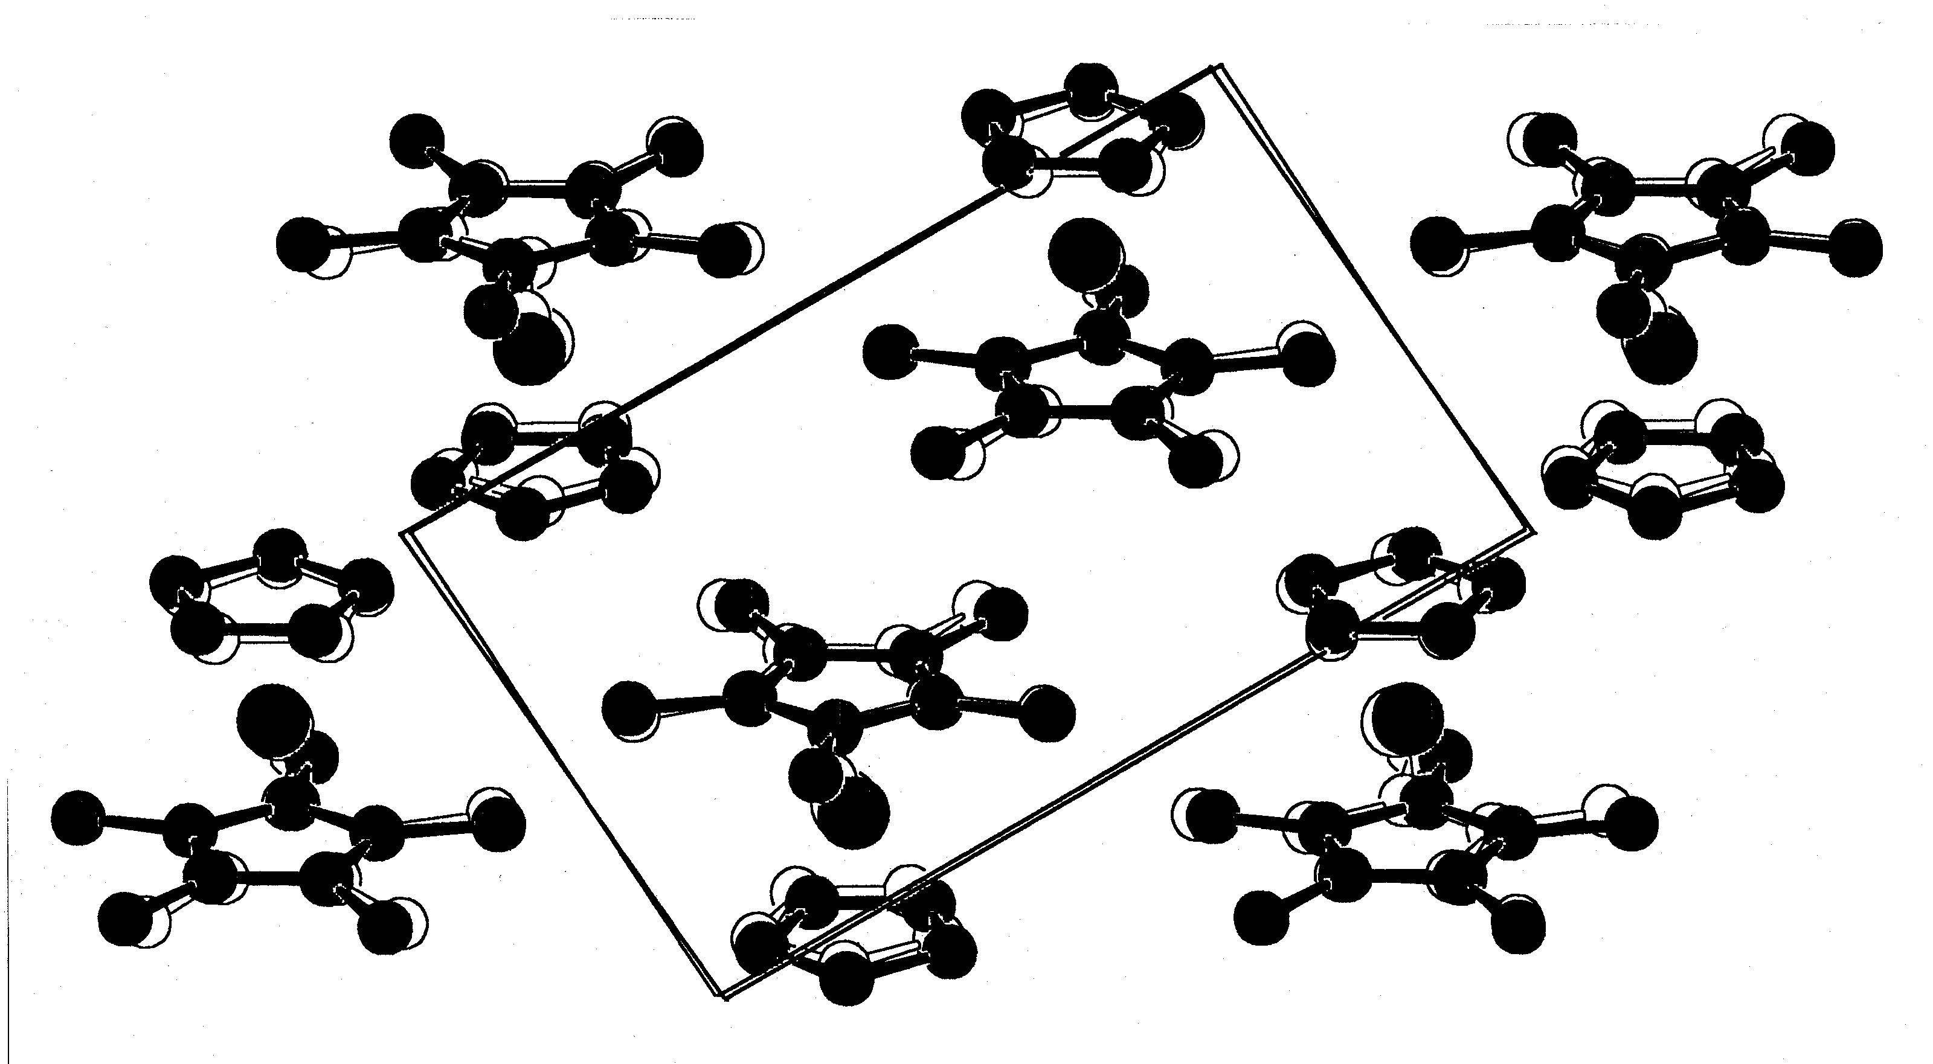

3. Determination of crystal structures from powder data by energy minimization

Crystal structures of molecular compounds with more than 80 atoms can be solved from X-ray powder data by energy minimization. The procedure consists of six steps:
1. Indexing of the powder diagram (Rate of success: about 50%) and deduction of the possible space groups. If indexing is not possible, energy minimization can be performed as well, but larger calculation times are needed.
2. Set-up of the molecular geometry.
3. Calculation of the possible crystal structures by lattice energy minimization.
4. Calculation of the powder patterns for the possible crystal structures.
5. Selection of the correct solution by comparing the calculated with the experimental powder diagrams.
6. Fit onto the full powder diagram by Rietveld refinement [].
(Warning: The procedure is not as easy as it seems to be. It is not a black-box tool!)
In this way, the following crystal structures were solved from X-ray powder data:
Pigment Yellow 12 (R=R'=H)
Pigment Yellow 13 (R=R'=CH₃)
Pigment Yellow 14 (R=CH₃, R'=H)
Perinone pigment [] Benzimidazolono-Dioxazine pigment

References

1. Schmidt, M.U. and Englert, U. (1996) Prediction of crystal structures, J. Chem. Soc. Dalton Trans. 1996, 2077-82.
. Schmidt, M.U. (1995) Kristallstrukturberechnungen metallorganischer Molekülverbindungen, Verlag Shaker, Aachen, Germany.
. Timofeeva, T.V., Chernikova, N.Yu. and Zorkii, P.M. (1980) Theoretical calculation of the spatial distribution of molecules in crystals, Uspechi Chimii 49, 966-997; Russian Chemical Reviews 49, 509-525.
. Hofmann, D.W.M. and Lengauer, T. (1997) A discrete algorithm for crystal structure prediction of organic molecules, Acta Cryst. A53, 225-235.
. Motherwell, W.D.S. (1998) Crystal structure prediction and the Cambridge crystallographic database, International School of Crystallography: "Implications of Molecular and Materials Structure for New Technologies", Erice, 28 May - 7 June 1998, Poster Abstracts P. 40.
. Gdanitz, R.J. (1992) Prediction of molecular crystal structures by Monte Carlo simulated annealing without reference to diffraction data, Chem. Phys. Lett. 190, 391-96.
. Tajima, N., Tanaka, T., Arikawa, T., Sakurai, T., Teramae, S. and Hirano, T. (1995) A heuristic molecular-dynamics approach for the prediction of a molecular crystal structure, Bull. Chem. Soc. Jpn. 68, 519-527.
. Wawak, R.J., Gibson, K.D., Liwo, A. and Scheraga, H.A. (1996) Theoretical prediction of a crystal structure, Proc. Natl. Acad. Sci. USA 93, 1734-36.
. Gavezzotti, A. (1991) Generation of possible crystal structures from the molecular structure for low-polarity organic compounds, J. Am. Chem. Soc. 113, 4622-29.
. Karfunkel, H.R. and Gdanitz, R.J. (1992) Ab initio prediction of possible crystal structures for general organic molecules, J. Computat. Chem. 13, 1171-83.
. van Eijck, B.P., Mooij, W.T.M. and Kroon, J. (1995) Attempted prediction of the crystal structures of six monosaccharides, Acta Cryst. B51, 99-103.
. Williams, D.E. (1996) Ab initio molecular packing analysis. Acta Cryst. A52, 326-328.
. Verwer, P. and Leusen, F.J.J. (1998) Computer simulation to predict possible crystal polymorphs, Reviews in Computational Chemistry 12, 327-365.
. Schmidt, M.U. and Kalkhof, H. (1997) CRYSCA, Program for crystal structure calculations of flexible molecules, Clariant GmbH, Frankfurt am Main, Germany.
. Dinnebier, R.E., Dollase, W.A., Helluy, X., Kümmerlen, J., Sebald, A., Schmidt, M.U., Pagola, S., Stephens, P.W. and van Smaalen, S. (1999) Order - disorder phenomena determined by high-resolution powder diffraction: the structures of tetrakis(trimethylsilyl)methane C(Si(CH₃)₃)₄ and tetrakis(trimethylsilyl)silane Si(Si(CH₃)₃)₄, Acta Cryst. B, submitted.
. Gavezzotti, A. (1994) Are crystal structures predictable? Acc. Chem. Res. 27, 309-314.
. Chaka, A.M., Zaniewski, R., Youngs, W., Tessier, C., Klopman, G. (1996). Predicting the crystal structure of organic molecular materials, Acta Cryst. B52, 165-183.
. Leusen, F.J.J. (1994) Ab initio prediction of possible crystal structures, Z. Krist. Suppl. 8, 161.
Schmidt, M.U. and Englert, U. (1995) Prediction of Crystal Structures for Organic and Organometallic Compounds, European Crystallographic Meeting 16, Lund/Sweden, 6.-11.8.1995.
. Englert, U., Herberich, G.E. and Schmidt, M.U. (1993, submitted 1992) Vorhersage der Kristallstruktur von Pentamethylferrocen, Z. Krist. Suppl. 7, 44.
. Zanin, I.E , Antipin, M.Yu., Struchkov, Yu.T., Kudinov, A.R. and Rybinskaya, M.I. (1992) Molecular and crystal structure of pentamethylferrocene (η⁵-C₅H₅)Fe(η⁵-C₅Me₅) in the interval 153-293 K. Analysis of the thermal motion in the crystal using X-ray diffraction data (in Russian), Metallorganicheskaya Khimiya 5, 579-89.
. Keller, E. (1997). SCHAKAL97, Kristallographisches Institut der Universität, Freiburg, Germany.
. Rietveld, H.M. (1969) A profile refinement method for nuclear and magnetic structures, J. Appl. Cryst. 2, 65-71.
. Schmidt, M.U. and Dinnebier, R.E. (1999) Combination of energy minimizations and rigid body Rietveld refinement: The structure of 2,5-dihydroxy-benzo[de]benzo[4,5]imidazo[2,1-a]isoquinolin-7-one, J. Appl. Cryst. 32, 178-186.

