The Super-D2B High Resolution Powder Diffractometer
E. Suard and A.W. Hewat, ILL

The most cited ILL work ever concerned the establishment of the “charge reservoir” concept for oxide superconductors, and the understanding of magnetic and charge ordering in CMR materials, both done on D2B. Yet these experiments are at the limit of the resolution and intensity of the machine. We propose an order of magnitude improvement, using a new type of pseudo-2D detector covering a much larger solid angle but at the same time permitting very high resolution. The required new technology has already been prototyped, and the costs and time scale well defined.

Of the more than 5000 publications produced by ILL since 1981, 50 papers were cited many more times than others1; as much as 20% of this high profile work was done using D1A/D2B !
(Zeolite catalysts, Superconductors, Giant Magnetic Resonance materials, Ice-phases etc).

High temperature oxide superconductors
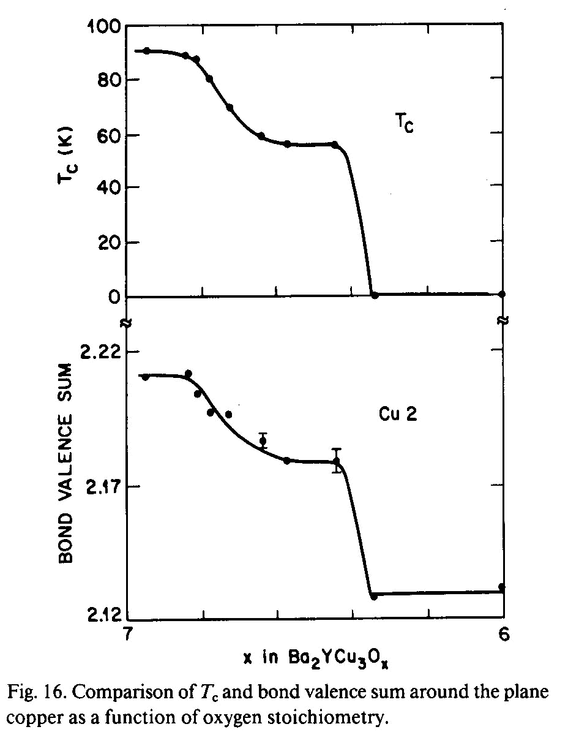
By studying small structural changes as a function of oxygen stoichiometry, we concluded2 with Bell labs. that oxidation-reduction of a “charge reservoir” layer could control the hole doping in copper oxide layers responsible for super-conductivity. These ideas lead immediately to a successful search for new materials with different “charge reservoir” layers, such as those with oxides of bismuth, thallium and mercury.
These subtle effects in heavy metal oxides are much better studied with neutrons, which are more sensitive to scattering from oxygen, especially since new materials are at first available only as powders. A common problem is that chemists can often only make very small quantities of new materials.
For example, the Raveau group have recently synthesized a new copper oxide at high pressure, but only 100 mg of sample is available, requiring an impractically long measuring time on the present D2B with the necessary high resolution.

Mixed Valence, Charge Ordering and Giant Magneto-Resistance
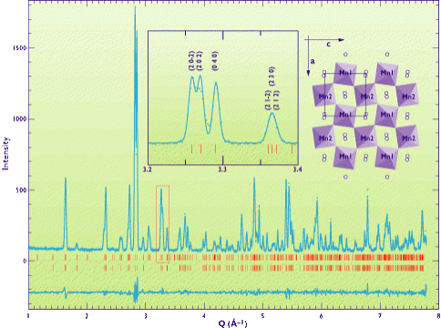High temperature superconductors are only one example of the many interesting materials found in recent years whose properties depend on order-disorder of the mixed valence states of one or more of the atoms. A recent example is that of charge and magnetic ordering in CMR manganites. Ordering is only within domains, so the average structure of a “single crystal” appears unchanged, and again it involves subtle movements of the heavy and light atoms, which are best seen with neutrons. Whether ordering appears as “stripes” or “ladders” has generated great interest, and measurements on D2B, coupled with synchrotron powder diffraction, has been essential to answer these questions3. The problem here is that the highest resolution is needed to resolve the line splitting, and the present D2B flux/resolution is not really sufficient.
What other new science will be possible with super-D2B ?
The superconductor and CMR work has made neutron diffraction one of the best known techniques for the study of metal-insulator transitions, one of the hottest current topics in solid state science. A recent Phys.Rev.Letter4 reported D2B work on charge disproportionation in rare-earth nickelates; a complete understanding requires a study with different rare earths as a function of temperature. Unfortunately only mg quantities of these materials are available since they are produced under high pressure, yet high resolution is needed to see the small structural distortions. Synchrotron diffraction has been tried, but failed to measure the small displacements of the light oxygen atoms with sufficient precision.
Much more exiting new science would be possible with such a machine. For example, new forms of meta-stable ice have recently been discovered at ILL on D2B by Kuhs and Finney, but again working at high pressure means very small samples, and high resolution is needed to sort out the different ice phases. The chemistry of hydrocarbons in zeolite catalysts is another hot topic studied by Fuess, Baehtz and others. These synthetic zeolites are not available as crystals, and again we are interested in the coordination of light atoms, which cannot be located with X-rays without good single crystals.

What can we do to increase both flux and resolution on super-D2B?
We propose to build a unique new type of pseudo-2D high resolution position sensitive detector. In the horizontal plane, high resolution would be obtained by scanning a large bank of very fine 5 minute collimators. In the vertical plane lower resolution would be obtained using a stack of linear wire position sensitive detectors. We have already had prototypes of 300 mm high collimators built by Euro-Collimators, and the detectors too, are commercially available in Europe. The cost is then well known: 1.35 MFF for the collimators and 1.25 MFF for the detectors to which we must add 0.4 MFF for shielding, to be made locally.
Such a detector would collect 6 times as many neutrons for the same resolution, and allow the highest possible resolution to be used for most problems. Following this proposal, a similar detector has been planned for the new Munich reactor, but with lower resolution and flux. (Indeed, if we do not modernize our own equipment, we will lose the advantage of our high flux reactor).

The proposed new high-resolution pseudo-2D detector for ILL’s super-D2B.
References
For more information, see the ILL’s Diffraction Group Millennium Proposal (http://www.ill.fr/dif/2000/)
1) According to the US Institute for Scientific Information (see: http://www.ill.fr/dif/citations/)
2) Cava, R. J., Hewat, A. W., Hewat, E. A., Batlogg, B., Marezio et al. (1990) Physica C. 165, 419.
Structural anomalies oxygen ordering and superconductivity in oxygen deficient Ba2YCu3Ox.
3) Hwang,H.Y.,Cheong,S.W.,Radaelli,P.G.,Marezio,M. and Batlogg,B. (1995) Phys. Rev. Letters. 75, 914.
Lattice effects on the magnetoresistance in doped LaMnO3.
Caignaert,V.,Suard,E.,Maignan,A.,Simon,C. and Raveau,B. (1996) J.Mag.& Mag.Mat.153: L260.
Neutron diffraction evidence for antiferromag. ordering in the CMR manganites Pr0.7Ca0.3-xSrMnO3.
Radaelli,P.G.,Cox,D.E.,Capogna,L.,Cheong,S.W.,Marezio,M. (1999) Phys. Rev. B.
Wigner Crystal and stripe models for the magnetic and crystal. superstructures of La0.333Ca0.667MnO3.
4) Alonso,J.M., Garcia-Munoz,J.L., Fernández-Díaz,M.T. et al. (1999) Phys. Rev. Letters 82, 3873.
Charge disproportionation in RNiO3 perovskites: metal-insulator & structural transition in YNiO₃
Other people’s opinions of the super-D2B project.
At the April 1999 Science Council meeting, the magnetism college chairman (R. Cywinski) in his report gave an order of priority for the Millennium programme, with first priority going to super-D2B, followed closely by D3-polarimetry. He wrote “The subcommittee expressed its strongest support for the super-D2B high-resolution diffractometer upgrade... the principal advantage of the proposed order of magnitude increase in intensity would not be that more experiments could be performed, but that new science would ensue”. He referred to charge density ordering, incommensurate and complex magnetic structures, the interplay of magnetic and structural transitions, small moment systems, and new possibilities for exploring complex systems in the parameter space of temperature, pressure, magnetic field and composition.
The Crystallography college chairman (W. Kuhs) wrote “Over one hour was devoted to the discussion…the highest priority was given ex aequo to Thermal LADI and the D2B upgrade. Both proposals were considered of outstanding quality, both in its scientific case and its technical feasibility”. In a letter to D. Dubbers, he wrote “I have seen the minutes of the last scientific council… that the scientific case should be strengthened… I had the strong impression that a good scientific case was made in the powder workshop…”. He referred to the work of his group on recently discovered phases of ice and clathrates at high pressure, and pointed out that increased intensity was needed for the study of such meta-stable and transient phases.
The chairman of the Science Council Powder Review (C. de Novion) wrote in his interim report on instrument upgrades, after organizing a workshop attended by many participants from both pulsed and synchrotron sources “The super-D2B upgrade project, presented within the new ILL Millennium Programme, was considered as a first priority, in particular the new (and higher) detector set. This would allow to use routinely the D2B instrument in its highest resolution mode”. In his final report in October, he wrote “It is rated as first priority by the Subcommittees 5a and 5b, which answer partially at least, to the requirement of the S.C. (“scientific case needs to be strengthened…). The first part of the project, new detectors and collimators, is well defined and has a good scientific return on investment ratio”.
Indeed, the new chairman of the Crystallography college (M. Latroche) wrote in his October report “… the subcommittee still strongly supports the D2B project. Structural determination by powder diffraction is a basic work that cannot be bypassed…” In a letter to D. Dubbers, he wrote “Our research group has shown the complementarity between neutron and synchrotron techniques by solving complex structures using joint refinement… from D2B and BM16 at ESRF. These structures cannot be solved from synchrotron data alone, and neutron data were essential…”
The Magnetism college chairman (R. Cywinski) further wrote in October “The subcommittee expressed its strongest and unequivocal support for the super-D2B high resolution diffractometer upgrade”. “Several Experiments proposed during this round underlined the need for both high resolution and high count rate”. He went on to give examples of D2B highlights including a new one dimensional cuprate that can only be synthesized in very small quantities under very high oxygen pressure. He concluded, “… longer term issues should not cloud the case for an urgent, well argued, and readily achievable upgrade to the present D2B”.

