L2-Organometallics -5A
Other π-acceptor ligands

2. Phosphines PR₃
These are an extremely important class of ligands. The P atom can be both a σ-donor and a π-acceptor. Which is these is most important depends on the nature of the R group.

If the R group is electron donating (inductive) e.g. Me, CMe₃ then phosphine is good σ-donor.

If the R group is electron withdrawing, e.g. F then phosphine acts as a π-acceptor - PF₃ is as good a π-acceptor as CO.

Ligand always is terminal (bridging phosphines virtually unknown), and is a TWO electron donor - Ni(PF₃)₄ is 18-e

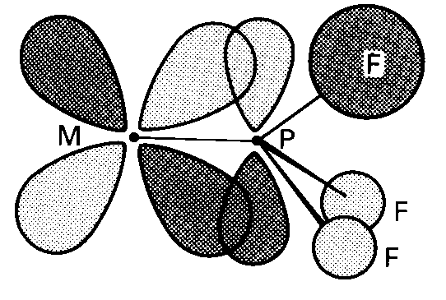
L2-Organometallics -5B
Other π-acceptor ligands
3. Alkenes
First organometallic compound made - Zeise's salt - 1827. Made by reaction of reaction of KCl, PtCl₂ in ethanol.
Original formulation - a double salt KCl.PtCl₂.EtOH

Actually shown (1955) to be potassium salt of an anionic ethene-complex K⁺ [PtCl₃(C₂H₄)]⁻.H₂O (same empirical formula)

X-ray structure shows a square-planar platinum(II)

The bonding in this compound has similarities with previous
examples of π-acceptor ligands. The experimental evidence
shows :
- The C=C bond is weakened when complexed with transition metal. In free ethene the C=C bond length is 1.34Å, in Zeise's salt it is 1.35Å
- IR stretching frequency of C=C bond drops also (but not as easily seen as in CO)
L2-Organometallics -5C
Other π-acceptor ligands
Dewar-Chatt-Duncanson model

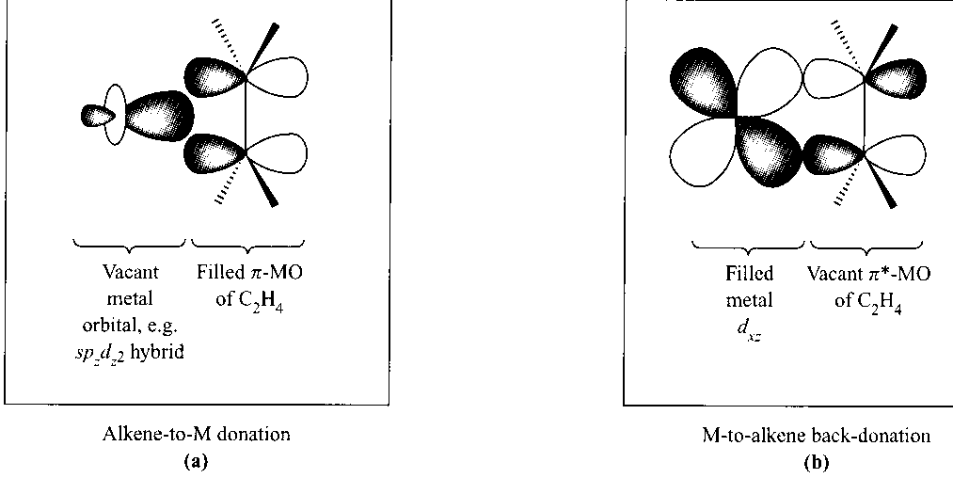

Side-on π-bonding. Involves donation from C=C π-bond to empty metal d-orbitals and backdonation from filled metal d-orbitals to π* orbitals - synergic bonding (H/S p 588)
Most stable alkene complexes are found with metals in low oxidation states, e.g. Ag(1), Cu(1), Fe(O)

Alkenes are TWO electron donors (like CO). In polyalkenes each double bond acts as a 2e-donor. For example cyclo-octa-1,5-diene has a pair of double bonds
Each double bond in cod contributes 2e, so electron count is
4 (for cod) plus 8 (Fe) plus 6 (3CO) = 18 e
L2-Organometallics -5D
Other π-acceptor ligands

4. Conjugated cyclic polyenes
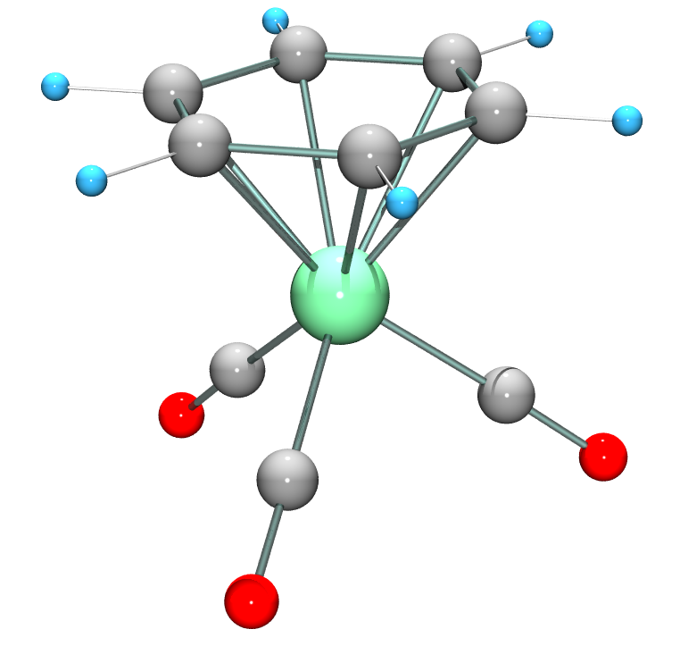
(C₆H₆)Cr(CO)₃

The commonest examples are cyclopentadienyl (C₅H₅) and benzenes . Here the transition metal binds to all the C atoms of the ring, giving the sandwich and half sandwich compounds

The rings are aromatic and fully conjugated (all atoms equivalent). The number of electrons donated to the metal usually is the same as the number of C atoms attached to the metal.
(C₅H₅)₂Fe Fe(= 8) plus 2 x 5 (C₅H₅) = 18
(C₆H₆)Cr(CO)₃ Cr(=6) plus 6 (3CO) plus 6 (C₆H₆) = 18
L2-Organometallics -5E
Other π-acceptor ligands
Cyclopentadienyl complexes

Of great historical importance - 1950's renaissance of Inorganic chemistry started by discovery of ferrocene
Ferrocene discovered simultaneously in 1951 by Wilkinson & Pauson (Wilkinson got Nobel prize for this work)

Structure by X-ray crystallography is a highly symmetrical "sandwich compound"
All 10 H's chemically identical (one signal in ¹H NMR spectrum)
All 10 C's also identical

The C₅H₅_ anion and ferrocene contain aromatic 6-π electron rings and the rings in ferrocene react easily by electrophilic substitution (like benzene).
L2-Organometallics -5F
Other π-acceptor ligands

Thousands of derivatives of ferrocene now known. Some have commercial uses, e.g. redox reaction
Fe(C₅H₅)₂ ⇆ [Fe(C₅H₅)₂]⁺ (ferrocinium cation) + e⁻

The "ExacTech" pen meter is used to measure blood glucose levels. It uses a ferrocene derivative

The redox active ferrocene derivative facilitates electron transfer between glucose and glucose oxidase, and allows a quick measure of glucose concentration.

Easy to use - particularly for children suffering from diabetes
L2-Organometallics -5G
Other π-acceptor ligands

Other π-conjugated ring systems which act as ligands
C₇H₇⁺ C₆H₆ C₄H₄ C₃H₃⁺
tropylium benzene cyclobutadiene cyclopropenium

18 e- rule applies to all these compounds
V 5 Cr 6 Fe 8 Co 9
C₇H₇ 7 C₆H₆ 6 C₄H₄ 4 C₃H₃ 3
3CO 6 3CO 6 3CO 6 3CO 6
18 18 18 18
Open conjugated ring systems also act the same

butadiene C₄H₆ allyl C₃H₅
4e donor 3e donor

