Chem-2X-Organometallics

Textbooks
Housecroft & Sharpe Inorganic Chemistry
Main group - Chapter 18, p 410
Transition metals - Chapter 23, p 584

Claydon, Greeves, Warren & Wothers Organic Chemistry
Main group - Chapter 9 & Chapter 47
Transition metals - Chapter 48

Metal-organo compounds can be conveniently divided into those containing
(a) Main group metals s-block (Na, Mg..) & p-block (Al, Sn, Bi .. & Zn)
(b) Transition metals Ti-Cu

All contain a polar M^{δ+}-C^{δ-} bonds - some more polar than others ......

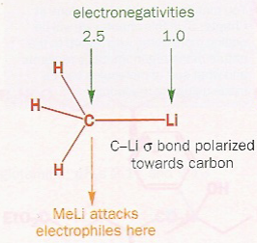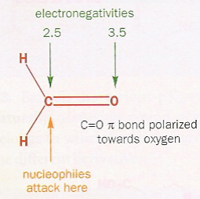

This polarisation of the M-C bond is extremely useful in synthesis

R₂C^{δ+}=O^{δ-} + LiCH₃ → R₂MeC-OLi → R₂MeC-OH
hydrolysis

ketone/aldehyde → alcohol

A huge variety of organic molecules can be bonded to metals, especially transition metals.

Examples include : alkyl & aryl groups, alkenes, alkynes, CO (carbonyls)

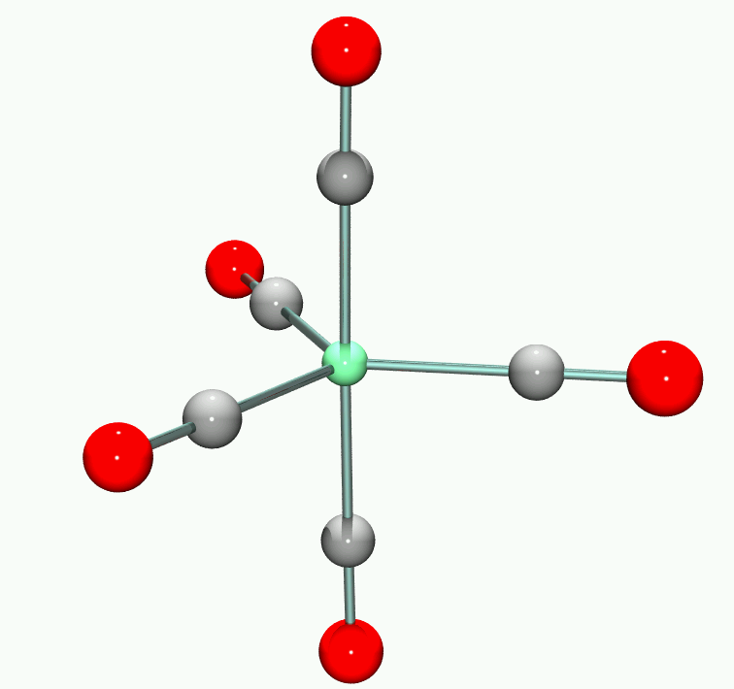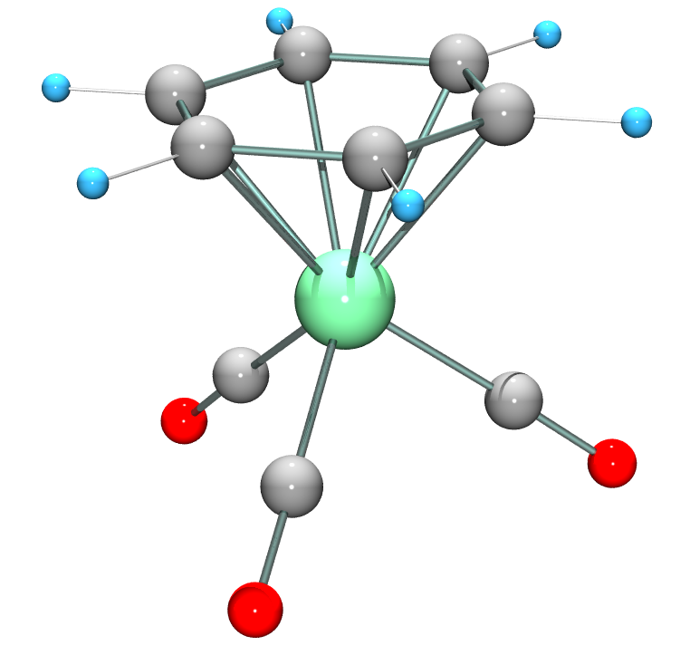

Fe(CO)₅ Cr(CO)₃(C₆H₅)

First look at main group organometallics and how they are prepared ........
Synthesis

1. Metal and organic halide

RX + Mg→ RMgX (Grignard reagent)

CH₃Cl + 2Li → LiCH₃ + LiCl (organo-lithium reagent)

Use donor solvents, e.g. ethers tetrahydrofuran (THF)

Aluminium (Al) and zinc (Zn) also work well, along with other active metals
Other metals may need more forcing conditions (e.g. higher temperatures, sonication)

The formation of chloromethylsilanes has great commercial importance

While these reactions can look simple from the equations, they are in reality quite complex
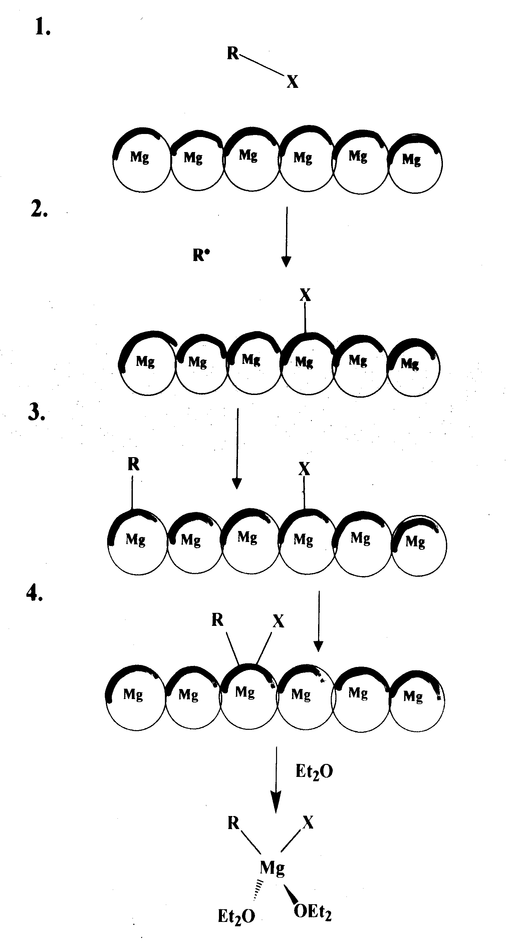
Formation of Grignard reagents

Synthesis

2. Metathesis reactions (exchange of partners)

The electronegative halide ends up with the most electro-positive metal, so that the new organometallic compound has less polar M-C bonds and is less reactive.
e.g
Special case of metathesis - redistribution reactions

Synthesis
3. Hydrometallation

A metal hydride adds to an unsaturated link. This is a vital (and reversible) step in transition metal organometallic reactions and catalysis. Becoming important in main group chemistry also ....

4. Trans-metallation
Direct reaction can transfer an organic group to a more reactive metal

(Neither benzyl-lithium nor vinyl-lithium can be made by direct reaction from the metal plus organic halide)

5. Metal-Hydrogen exchange
A carbanionic R group will combine with an acidic hydrogen on a hydrocarbon, forming a new reagent

RMgX + R'C≡CH → R'C≡CMgX + RH
Compound types and reactivity

Group |  | 1 |  | 2 |  | 12 | 13 | 14 | 15
Example |  | LiCH₃  (MeLi) |  | PhMgBr  MgMe₂ |  | ZnEt₂  HgMe₂ | AlMe₃ | SiMe₄ | AsPh₃  SbMe₃
Element |  | Li |  | Be |  |  | B
 |  | Na |  | Mg |  |  | Al | Si
 |  | K |  | Ca |  | Zn | Ga | Ge | As
 |  | Rb |  | Sr |  | Cd | In | Sn | Sb
 |  | Cs |  | Ba |  | Hg | Tl | Pb | Bi
A | B |  | C

A. Ionic compounds with very electropositive metals e.g. NaC₆H₅
Behaves as Na⁺ C₆H₅⁻ - an insoluble and pyrophoric (i.e. spontaneously inflame in air) solid. Not much practical use due to its insolubility.

B. Polar covalent compounds e.g. Grignard reagents CH₃^{δ-}-Mg^{δ+}-X.
They are reactive and are often useful compounds. All react with air and moisture, and some are pyrophoric

C. Compounds of less electropositive metals - they are covalent and often quite unreactive
Reactivity relationships
Reactivity falls sharply as elements become less electropositive

Reagent | MgMe₂ | ZnMe₂ | CdMe₂ | HgMe₂
O₂ | inflames | inflames | oxidises | inert
H₂O | explodes | explodes | hydrolyses | inert
CO₂ | reacts | reacts | inert | inert

Example of Main Group Organometallics - ZnEt₂

Varying reactivity means that main group organometallics can be used as specific reagents for specific purposes, e.g. Gilman reagent used to attack C-Br bond but not C=O bond.

Diethyl zinc was the first organo-metal compound made, by the British chemist Edward Frankland in 1850. Made from EtI and Zn and protected by a CO₂ or H₂ atmosphere - the compound is highly pyrophoric

ZnEt₂ is used nowadays to de-acidify the paper of important old books and documents (they become yellowed and brittle with time)

2H⁺ + ZnEt₂ → Zn²⁺ + 2 C₂H₆ ↑

Any moisture in the paper reacts to give the white, basic oxide ZnO,
which buffers further acidity

H₂O (in paper) + ZnEt₂ → ZnO + 2 C₂H₆ ↑

However, difficult to use because it is so reactive and dangerous.

Nature of Grignard reagents

R-Mg-X - simple formula belies a complicated situation.
Many species present in solution - known as Schlenk equilibria.

Evidence
(a) RMgX when treated with dioxane gives MgX₂.dioxane
Also mixtures of solutions of MgEt₂ and MgBr₂ are indistinguisable from solutions of EtMgBr.

(b) Molecular weights in solution are too big - indicates oligomers are present with 1-4 units. Clusters have now been isolated.

(c) Grignard reagents conduct electricity, indicating that ionic species are present in solution. Mg is deposited at both the cathode and anode.
Schlenk equilibria in Grignard reagents

2 RMgX(S)₂ ⇆ MgX₂(S)₂ + MgR₂(S)₂..........(a)

[XMg(S)₃]⁺, [RMg(S)₃]⁺, [R₂MgX(S)]⁻, [RMgX₂(S)]⁻ .......(c)

Here S is a solvent molecule (usually an ether molecule)

This horrible mixture is present in all Grignard solutions !!
Structure and bonding
Compounds of larger and less electropositive elements have structures just as the formulae suggest : SiMe₄ is tetrahedral and HgPh₂ is linear.

Some of the lighter and more electropositive metals tend to use their s and p orbitals to produce 4-coordination or greater, even when there are insufficient electrons to allow two electrons per bond.

Such molecules are called electron deficient and are quite common with Li, Be, Mg and Al

e.g "AlMe₃" is actually dimeric, Al₂Me₆ with bridging methyl groups
Al₂Me₆ is an excellent carbanionic methylating agent
SiO₂ + Al₂Me₆ → SiMe₄

It can be made in the lab by trans-metallation

Al + HgMe₂ → Al₂Me₆ + Hg
Structure and bonding
Each Al is sp³ hybridised and is bonded to four C atoms, but there are not enough electrons to assign a pair of electrons per chemical bond.
This is common in aluminium alkyls and similar electron deficient bridges are found in other alkyls, e.g. MgMe₂ and BeMe₂ are polymeric through bridging methyl groups ...

Be(CMe₃)₂ is a linear molecule because tertiary butyl group is large ! Lithium methyl is tetrameric (LiMe)₄ - cubane structure in solid and solution.
No bonds between Li atoms !
Solvation of organometallics

Compounds of the electropositive metals are energetically solvated, e.g. BeR₂ RMgX, ZnR₂, AlR₃
Complex formation prior to any reaction is almost certain to occur as part of the reaction sequence, e.g. hydrolysis of aluminium alkyls to give alkanes.

1/2 Al₂R₆ + H₂O → [H₂O→AlR₃] → AlR₂(OH) + RH

CdR₂ is less energetically solvated and reacts more slowly, while HgR₂ has practically no tendency to increase its coordination above two (and hence form complexes like Mg above).

This accounts for the inert behaviour of HgMe₂
HgMe₂ + H₂O → HgO + 2CH₄ ΔH ⁰ = -8 kJ mol⁻¹

Reactions doesn't go and HgMe₂ is kinetically stable because a solvated intermediate is not formed. This is why HgMe₂ and methyl mercury derivatives such as MeHg⁺ are so dangerous in the environment.

Minamata disaster - methyl mercury poisoning
http://www.american.edu/TED/MINAMATA.HTM

From 1932 to 1968, the Chisso Corporation, a company located in Kumamoto Japan, dumped an estimated 27 tons of mercury compounds into Minamata Bay. The town consists of mostly farmers and fisherman.

Thousands of people whose normal diet included fish from the bay unexpectedly developed symptoms of methyl mercury poisoning. The illness became known as the "Minamata Disease" and over 3000 victims have been compensated in the Japanese courts.

The mercury compounds were absorbed by sea organisms and converted to methyl mercury derivatives and passed into the food chain.

Methyl mercury and derivatives are serious neurotoxins !

The phrase "Mad as a hatter" comes from a similar poisoning. In the 18th & 19th centuries, hatters utilised treatement of hat-felt with mercury compounds.

The story so far ....

1. Organometallic compounds of electropositive main group elements are very reactive. Those of less electropositive metals are less so (but react more selectively)

2. The compounds can be prepared by direct reaction of metals and organic halides, by adding a metal-hydrogen bond across a C=C bond, or by transfer of organic groups between metals.

3. Grignard reagents in solution involve many complex equilibria between several organometallic species

4. Organometallic compounds of the light elements (e.g. Li, Be, Mg, Al) are often electron deficient, with bridging R groups and 2-electron 3-centre bonds.

5. These electron deficient compounds tend to react readily with electron rich species, e.g. electron pair donors (solvent
or multiple bonds)

Solvent effects on Grignard reagents

1. Powerful electron donors
These confer carbanion behavior on RMgX, e.g. HMPA
This is a powerful solvent of high dielectric constant, high polarity and low reactivity ( and is carcinogenic !)

PhCH₂MgCl in HMPA has the characteristic red colour of PhCH₂⁻ carbanion. This reagent is a better metallating reagent then normal (ether) Grignard reagents
PhCH₂⁻ + Ph₂CH₂ → Ph₂CH⁻ + PhCH₃

2. Chiral solvents
These allow Grignard reagents to be used in enantioselective
syntheses.

RR'C=O + R''MgX → RR'R'' *C-OH
prochiral ketone excess of one enantiomer

Example of chiral solvent (+)(S)-EtMeHC*-CH₂OEt

Now move onto transition metal organometallics ........
Metal carbonyls

Ni(CO)₄ nickel tetracarbonyl - Ludwig Mond (1889)

A toxic, colourless volatile liquid (b.pt 43 ºC), is easily decomposed. It has a tetrahedral structure.

Fe(CO)₅ iron pentacarbonyl - Berthelot, Mond (1891)

Yellow liquid, trigonal bipyramidal structure. Made from Fe
and CO at 200 ºC and high pressure

These are the ONLY two carbonyls which can be made by direct reaction of metal and CO. Others require in-situ reduction and/or high pressure

Cr(CO)₆ a white crystalline solid - Mo(CO)₆, W(CO)₆ v. similar
Stability order Cr(CO)₆ > Fe(CO)₅ > Ni(CO)₄

U(CO)₆ ? possible volatile Uranium comp for nuclear industry
Metal carbonyls
Questions
- What holds these compounds together ? (metals have no charge)
- Why the different numbers of CO ligands ?

Need to understand the molecular orbitals of CO
(Housecroft/Sharpe p42)

CO has (a) filled sigma (σ) bonding orbital - the donor orbital
(b) empty pi(π*) antibonding orbital - acceptor orbital

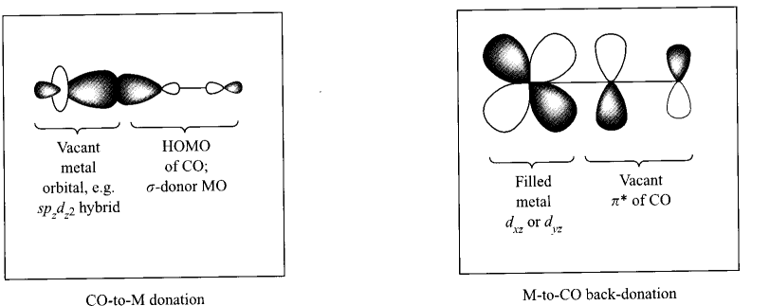Both these orbitals are used to make bonds with the d-orbitals on the transition metal. They both have the same symmetry and similar energies to the metal d-orbitals.

Housecroft/Sharpe diagram page 585

Metal carbonyls

The CO transfers electrons to the metal through the sigma-bond, but the metal transfers electrons to the CO through the pi-bond. This two-way flow of electrons is known as back-bonding or synergic bonding. It is self re-inforcing, so makes for strong bonds (M-CO bond strength is greater than a single bond).

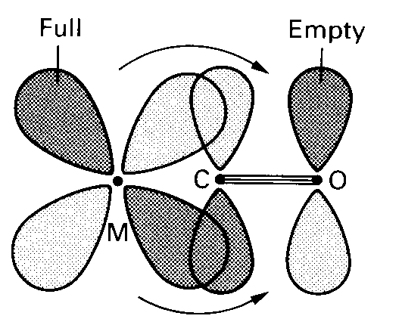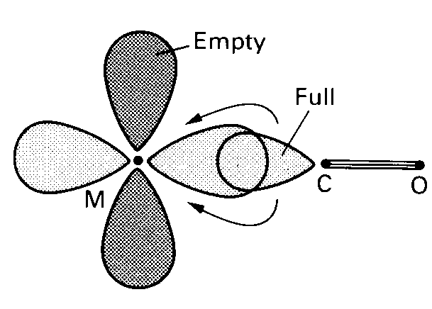

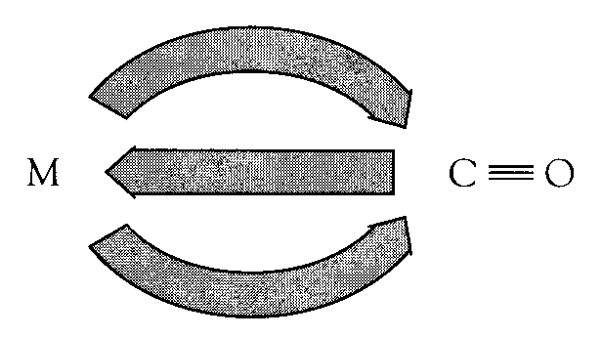

Effects of π-bonding ligands

CO and related ligands are called π-acceptor ligands

1. Effect on the metals

Removal of electron density can stabilise metals in low oxidation levels (zero or below).
Fe(CO)₅ contains Fe(0) zerovalent compound
Na₂Fe(CO)₄ contains Fe(-2)

2. Effect on the ligands

As the π* (antibonding) orbitals are populated the C≡O bond order is reduced (from 3 to 2.something) and the bond is weakened.
The evidence for this comes from :

- X ray crystallography - there is a small increase in the C-O bond length
- IR spectroscopy - the ν(CO) stretch in free CO is 2148 cm⁻¹ but in carbonyl complexes it is lower, ~ 2000 cm⁻¹ (in organic ketones the ν(CO) stretch comes ~ 1750 cm⁻¹)

18 electron rule

Second question : Cr(CO)₆ Fe(CO)₅ Ni(CO)₄
Why different number of CO ligands ?

Answer : 18 Electron Rule
Organometallic compounds will be most stable if they have 18 valence electrons in total.

This is an important empirical rule, i.e. the result of many observations and has no really sound justification in theory.

Best way to think of it is like the octet rule - the transition metal is trying to attain the rare gas configuration.

Transtion metals have 9 valence orbitals - for first row metals five 3d, one 4s and three 4p. Most stable if all are filled.

Electrons come from both the metal and ligands.

CAVEAT : 18 Electron Rule ONLY applies to transition metal organometallic compounds, generally with π-acceptor ligands.

18 electron rule

Using the 18 Electron Rule

Count all the valence (outer) electrons of the metal and those donated to the metal by the ligands (usually 2 per lone pair)

Cr(CO)₆ Cr has six valence electrons (e⁻) d ⁶ 6
6 CO ligands → 6 x 2 = 12 e⁻ 12
18

Ni(CO)₄ Ni has ten valence electrons (e⁻) d ¹⁰ 10
4 CO ligands → 4 x 2 = 8 e⁻ 8
18

When there are an ODD number of electrons, the species usually dimerises with the formation of metal-metal bonds.

Metal-metal bonds can be regarded as normal covalent bonds, using ONE electron from each metal.

To apply the 18-electron rule to these compounds, do the count at EACH metal and add one more electron from the other metal. Often both halves are the same so only need to do this once.
18 electron rule

Mn(CO)₆ would have 19 electrons - so it is not stable and does not exist (but it can lose an electron to give the stable [Mn(CO)₆]⁺ which now has 18 e)

18-electron rule is very useful as it gives us a clue as to which molecular structures will be stable. There are almost NO stable organometallic compounds where the metal has more than 18 electrons.

18 electron rule

Cobalt is similar to manganese and gives Co₂(CO)₈. This molecule has several structures.

Co - 9
3CO_{terminal} - 6
2CO_{bridging} - 2
Co-Co bond - 1
18

The bridging carbonyl has a ν(CO) stretch in the infra-red (IR) spectrum ~ 1800 cm⁻¹ This is much lower than terminal carbonyls and more similar to an organic ketone R₂C=O which has a ν(CO) stretch ~ 1750 cm⁻¹
In solution Co₂(CO)₈ also has a structure with only terminal carbonyls, i.e. four per Co atom (this is also 18 e). Terminal ν(CO) stretches ~ 1950-2000 cm⁻¹

In exams need to know (1) 18-e rule (2) use of IR spectra

18 electron rule

All the simple carbonyls of the 1st row transition metals
Ni(CO)₄ Co₂(CO)₈ Fe(CO)₅ Mn₂(CO)₁₀ Cr(CO)₆
have formulae which can be understood in terms of the 18-electron rule.

But V(CO)₆ is a stable 17-electron compound - doesn't dimerise. Why?

Answer is steric reasons : Cannot get 6 carbonyl ligands around the V atom AND also get a V-V bond with another V(CO)₆ molecule - not enough space. So......

V(CO)₆ is paramagnetic (i.e. has unpaired electron) and is very reactive. Will easily gain an electron by chemical reduction to give the anion [V(CO)₆]⁻. This now satisfies the 18-e rule and is much more stable.
V - 5
6CO -12
-charge - 1
18

But CAN get a small ligand like H (hydride) - HV(CO)₆
This has a direct V-H bond

Other π-acceptor ligands

There are a multitude of other organic (and unsaturated) molecules which can bond to transition metals in a similar way to CO
1. Nitrosyls (NO)
NO is similar to CO, but has an extra electron, so donates THREE electrons to a metal, e.g. Co(NO)(CO)₃
Co 9
NO 3
3CO 6
18
Another example Fe(CO)₂(NO)₂
Fe=8 plus 2x2 CO plus 2x3 NO = 18

Fe(CO)₃(NO) - this is 17e compound, so it dimerises to give an Fe-Fe bond (like Mn₂(CO)₁₀)

One way of viewing the bonding in nitrosyls

NO is more strongly bound than CO

Other π-acceptor ligands

2. Phosphines PR₃
These are an extremely important class of ligands. The P atom can be both a σ-donor and a π-acceptor. Which is these is most important depends on the nature of the R group.

If the R group is electron donating (inductive) e.g. Me, CMe₃ then phosphine is good σ-donor.

If the R group is electron withdrawing, e.g. F then phosphine acts as a π-acceptor - PF₃ is as good a π-acceptor as CO.

Ligand always is terminal (bridging phosphines virtually unknown), and is a TWO electron donor - Ni(PF₃)₄ is 18-e

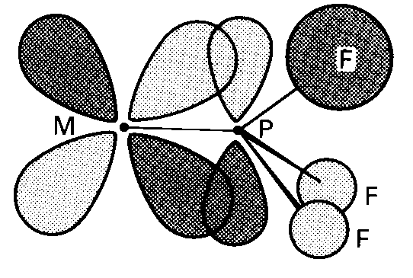
Other π-acceptor ligands
3. Alkenes
First organometallic compound made - Zeise's salt - 1827. Made by reaction of reaction of KCl, PtCl₂ in ethanol.
Original formulation - a double salt KCl.PtCl₂.EtOH

Actually shown (1955) to be potassium salt of an anionic ethene-complex K⁺ [PtCl₃(C₂H₄)]⁻.H₂O (same empirical formula)

X-ray structure shows a square-planar platinum(II)

The bonding in this compound has similarities with previous
examples of π-acceptor ligands. The experimental evidence
shows :
- The C=C bond is weakened when complexed with transition metal. In free ethene the C=C bond length is 1.34Å, in Zeise's salt it is 1.35Å
- IR stretching frequency of C=C bond drops also (but not as easily seen as in CO)
Other π-acceptor ligands
Dewar-Chatt-Duncanson model

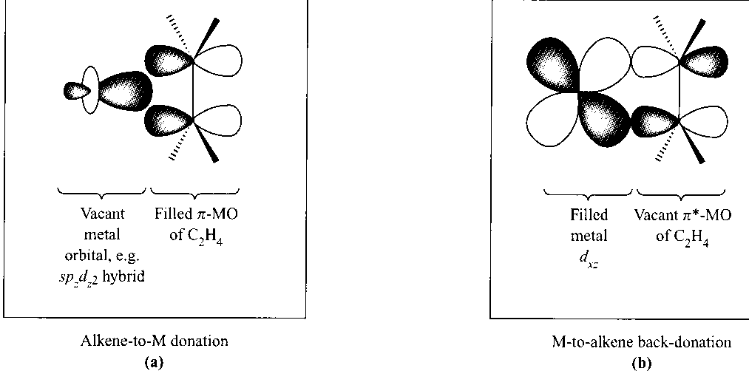

Side-on π-bonding. Involves donation from C=C π-bond to empty metal d-orbitals and backdonation from filled metal d-orbitals to π* orbitals - synergic bonding (H/S p 588)
Most stable alkene complexes are found with metals in low oxidation states, e.g. Ag(1), Cu(1), Fe(O)

Alkenes are TWO electron donors (like CO). In polyalkenes each double bond acts as a 2e-donor. For example cyclo-octa-1,5-diene has a pair of double bonds
Each double bond in cod contributes 2e, so electron count is
4 (for cod) plus 8 (Fe) plus 6 (3CO) = 18 e
Other π-acceptor ligands

4. Conjugated cyclic polyenes
(C₆H₆)Cr(CO)₃

The commonest examples are cyclopentadienyl (C₅H₅) and benzenes . Here the transition metal binds to all the C atoms of the ring, giving the sandwich and half sandwich compounds

The rings are aromatic and fully conjugated (all atoms equivalent). The number of electrons donated to the metal usually is the same as the number of C atoms attached to the metal.
(C₅H₅)₂Fe Fe(= 8) plus 2 x 5 (C₅H₅) = 18
(C₆H₆)Cr(CO)₃ Cr(=6) plus 6 (3CO) plus 6 (C₆H₆) = 18
Other π-acceptor ligands
Cyclopentadienyl complexes

Of great historical importance - 1950's renaissance of Inorganic chemistry started by discovery of ferrocene
Ferrocene discovered simultaneously in 1951 by Wilkinson & Pauson (Wilkinson got Nobel prize for this work)

Structure by X-ray crystallography is a highly symmetrical "sandwich compound"
All 10 H's chemically identical (one signal in ¹H NMR spectrum)
All 10 C's also identical

The C₅H₅_ anion and ferrocene contain aromatic 6-π electron rings and the rings in ferrocene react easily by electrophilic substitution (like benzene).
Other π-acceptor ligands

Thousands of derivatives of ferrocene now known. Some have commercial uses, e.g. redox reaction
Fe(C₅H₅)₂ ⇆ [Fe(C₅H₅)₂]⁺ (ferrocinium cation) + e⁻

The "ExacTech" pen meter is used to measure blood glucose levels. It uses a ferrocene derivative

The redox active ferrocene derivative facilitates electron transfer between glucose and glucose oxidase, and allows a quick measure of glucose concentration.

Easy to use - particularly for children suffering from diabetes
Other π-acceptor ligands

Other π-conjugated ring systems which act as ligands
C₇H₇⁺ C₆H₆ C₄H₄ C₃H₃⁺
tropylium benzene cyclobutadiene cyclopropenium

18 e- rule applies to all these compounds
V 5 Cr 6 Fe 8 Co 9
C₇H₇ 7 C₆H₆ 6 C₄H₄ 4 C₃H₃ 3
3CO 6 3CO 6 3CO 6 3CO 6
18 18 18 18
Open conjugated ring systems also act the same

butadiene C₄H₆ allyl C₃H₅
4e donor 3e donor

σ-bonded ligands
Like the main group metals, it is also possible for transition metals to form sigma-bonds (σ-bonds) to certain organo (and other) ligands.
Example 1.
Example 2

Each σ-bonded ligand CH₃, H (hydride), Cl or σ-C₃H₅ (allyl)
counts ONE electron towards the 18 electron rule.

Each σ-bonded ligand behaves as an ANION with a single negative charge (need to know to work out oxidation no.)
Stability of organometallics

Many attempted reactions to form transition metal-organometallic compounds fail, e.g.

EtMgX + PtCl₂ → "black tar"
but..... EtMgX + (Ph₃P)₂PtCl₂ → (Ph₃P)₂PtEt₂

The presence of additional π-bonding ligands (in this case a phosphine ligand PPh₃ - triphenylphosphine) stabilises the organo-transition metal compound.

The ability of transition metals to easily change their oxidation number or coordination number means that these compounds have available extra reaction pathways which can lead to decomposition.

One such mechanism is the β-elimination process

The β-H atom is transferred to the metal to give a metal hydride

β-elimination process
Example

The process requires
- a coordination site (made available by PR₃ loss)
- easy change from Co(+3) to Co(+1)
- transferred H is also eliminated by combining with the ethyl group to give ethane (reductive elimination)
oxidative addition & reductive elimination
NOTE : both the oxidation numbers and the coordination numbers change by 2.

Examples of reductive elimination - here there are TWO possible products, eliminating C₂H₆ or CH₃Cl
insertion reactions

Small unsaturated molecules (CO, alkenes, etc) can "insert" into the M-C bond of transition metal alkyls.

Carbenyl "migratory insertions" of "CH₂" increase the chain length by one, and functionalise the R group.

Example
(OC)₅MnCH₃ + L → (OC)₄(L)Mn-C(O)-CH₃ L = CO, PPh₃

CO group is apparently inserted into the Mn-CH₃ bond

Example
Alkene insertions take place in the Ziegler-Natta catalysed
polymerisations of ethene
Conclusions

- All these reactions involves either a change in the oxidation number or the coordination number of the transition metal (or both).

- These are typical properties of transition metals.

- Ligands such as C₅H₅ and other strongly π-bonded ligands can control or supress these reactions and can thus be used to stabilise transition metal organometallic compounds.

- Many of these reactions are easily reversible (low activation barrier) and are consequently very important in catalytic reactions.

Transition metal organometallics - summary

π-bonded compounds

- Ligands such as CO, NO and phosphines (PR₃) bind to low oxidation state transition metals by "synergic" π & σ bonds.
- Alkenes and other unsaturated organic molecules attach side-on to the metal atoms. They also are held in place by "synergic" π & σ bonds.
- low oxidation-state compounds of these types usually obey the 18-electron rule. CO, PR₃ are 2 e⁻ donors, NO is a 3 e⁻ donor and unsaturated organic molecules count 1 e⁻ for each C atom which is bonded to the metal.

σ-bonded compounds

- transition metal organometallics can undergo a variety of reactions not available to main-group compounds. These include β-elimination, reductive-elimination, oxidative-addition and insertion reactions.
- These above reactions can lead to decomposition of the compound, unless the coordination sites they need are firmly occupied by other ligands.

OXO or hydroformylation process

This is an example of a homogeneously catalysed process (all reactants in the same phase). The mechanism illustrates several of the reactions summarised above.

overall reaction RCH=CH₂ + CO + H₂ → RCH₂CH₂CHO

Catalyst is Co₂(CO)₈

There are TWO major commercial applications of this reaction
- R = Me i.e. propene → butanal (~ 3m tonnes per year)

2. R = hexyl i.e. 1-octene → nonanal (biodegradable detergents)
OXO or hydroformylation process -mechanism

CoCl₂ added as a "pre-catalyst" - converted under reaction conditions

CoCl₂ + H₂ + CO → Co₂(CO)₈

OXO or hydroformylation process -mechanism

Multi-stage "cyclical" reaction

Step 1. Reduction
Co₂(CO)₈ + H₂ → 2 HCo(CO)₄ "active catalyst" (18 e compd)

Step 2. Ligand replacement
CO is replaced by RCH=CH₂ HCo(RHC=CH₂)(CO)₃ (18 e)

The metal atom is "holding" the reactive species together.

Step 3. Insertion of alkene into Co-H bond
Hydride H atom adds to C atom of alkene

H(RCH=CH₂)Co(CO)₃ + CO → RCH₂CH₂ - Co(CO)₄ (18 e)

Step 4. Insertion of CO into Co-alkyl bond
RCH₂CH₂Co(CO)₄ + CO → RCH₂CH₂ - C(O) - Co(CO)₄ (18 e)

Step 5. Reduction and product elimination
H₂ adds oxidatively to metal complex and the product is then eliminated in a reductive elimination reaction

OXO or hydroformylation process

Process runs at 120ºC and at 200 atm pressure of CO

High CO pressure prevents loss of CO from cobalt atom, which would lead to decomposition. Reaction only 80% specific.

Divergence happens at stage 3. The H atom can add to the CH₂ group rather than the CHR group.

In commercial process one of the CO ligands on the cobalt is replaced by a bulky phosphine ligand PR₃

HCo(CO)₄ + PR₃ → HCo(CO)₃(PR₃) + CO (18 e)

The steric crowding at the Co atom forces the H addition to make the linear rather than branched chain isomer.
OXO or hydroformylation process

This "trick" enables the efficiency of the reaction to go from 80% yield of linear chain product, up to nearly 100%

This is one very important advantage of homogeneous catalysis.

HIGH SELECTIVITY (commercially important)

Disadvantages

Catalyst is in same phase as products - how to separate the two ??

HCo(CO)₄ + NaHCO₃ → Na⁺ [Co(CO)₄]⁻ (water soluble)
+ H₂O + CO₂

Catalyst can then be regenerated

Na[Co(CO)₄] + H₂SO₄ → HCo(CO)₄

Chem2X Organometallics course : specimen questions

June 2000

1. Manganese chloride, MnCl₂, reacts with one mole equivalent of C₅H₅Na then of C₆H₅MgBr to produce, after hydrolysis, a deep red crystalline product, A, that analyses as C, 66.68; H, 5.56; Mn, 27.73% and has a molecular weight of 198.13. The ¹H NMR spectrum of A shows two singlets at 3.83ppm (5H) and 4.50ppm (6H). Its ¹³C NMR spectrum similarly has two signals of relative intensities 5:6.

Interpret these data to identify A, and use the 18 electron rule to rationalise its structure.
[10]
Relative atomic masses: C, 12.01; H, 1.008; Mn, 54.94

August 2000

(2) Use the reactions with H₂O, O₂ and CO₂ to illustrate how the reactivity of simple organometallic compounds of the main group elements varies with the electronegativity of the element.
[7]

(3) The reaction of iodomethane and lithium in ether produces a crystalline,pyrophoric compound analysing as C, 54.66; H, 13.75; Li, 31.59% with a molecular weight of 87.90. Derive the formula of this compound and draw its likely structure. Describe the bonding within this molecule.
[8]
Relative atomic masses: C, 12.01; H, 1.008; Li, 6.94.

June 2002

(4) Phenylmagnesium bromide, PhMgBr, reacts with (C₅H₅)Fe(CO)₂Cl to produce a yellow, crystalline compound (A) which analyses as C, 61.4; H, 3.9; O, 12.6; Fe, 22.0%. A has strong IR absorptions at 2021cm⁻¹ and 1969cm⁻¹. Its ¹H NMR spectrum consists of two resonances, at 7.1ppm (5H) and 4.97ppm (5H).
Identify compound A and interpret its spectroscopic data.
Show that both (C₅H₅)Fe(CO)₂Cl and compound A conform to the 18 electron rule.
[10]
Relative atomic masses: C, 12.01; H, 1.008; Fe, 55.847.

August 2002

(5) Describe the working of the 18 electron rule, illustrating its application by reference to Cr(CO)₆ and Mn₂(CO)₁₀.
[6]
(6) Nitric oxide, NO, is a paramagnetic gas. It readily displaces three of the carbonyl ligands of Fe(CO)₅ to give the diamagnetic compound Fe(CO)₂(NO)₂.
Explain why NO is paramagnetic, but its transition metal complexes are diamagnetic. Explain why NO so readily displaces CO.
Does Fe(CO)₂(NO)₂ obey the 18 electron rule ? Give your reasons.
[9]

August 1999

(7) Explain the 18 electron rule and show how the following compounds adhere to this rule : Fe(C₅H₅)₂ Co₂(CO)₈ and Cr(CO)₃(C₆H₆).

June 1998

(8) Free CO gas has ν(CO) at 2140 cm⁻¹ in its IR spectrum. Crystalline Mn₂(CO)₁₀ has ν(CO) values near 2000 cm⁻¹ but crystalline Co₂(CO)₈ has IR carbonyl absorptions near both 2000 cm⁻¹ and 1800 cm⁻¹. Relate these observations to the structure and bonding in the compounds.

(9) Aluminium chloride reacts with methyl-lithium to produce a volatile liquid Y which spontaneously ignite in air and explodes in contact with water. Y analyses as C, 49.99; H, 12.58; Al, 37.43% and has a molecular weight of 144.
(i) Identify Y and describe its structure and bonding
(ii) Predict how Y would react with (a) ether and (b) ethanol
Relative atomic masses, C, 12.011; H,1.008;, Al, 26.98

(10) Methyl-lithium (excess) reacts with SiCl₄ to produce a colourless volatile and unreactive liquid X, which analyses as C₄H₁₂Si. The NMR spectrum of X consists of a singlet at 0 ppm.
Identify X and suggest reasons for its inert behaviour.

