L2-Organometallics -2A
Nature of Grignard reagents

R-Mg-X - simple formula belies a complicated situation.
Many species present in solution - known as Schlenk equilibria.

Evidence
(a) RMgX when treated with dioxane gives MgX₂.dioxane
Also mixtures of solutions of MgEt₂ and MgBr₂ are indistinguisable from solutions of EtMgBr.

(b) Molecular weights in solution are too big - indicates oligomers are present with 1-4 units. Clusters have now been isolated.

(c) Grignard reagents conduct electricity, indicating that ionic species are present in solution. Mg is deposited at both the cathode and anode.
L2-Organometallics -2B
Schlenk equilibria in Grignard reagents

2 RMgX(S)₂ ⇆ MgX₂(S)₂ + MgR₂(S)₂..........(a)

[XMg(S)₃]⁺, [RMg(S)₃]⁺, [R₂MgX(S)]⁻, [RMgX₂(S)]⁻ .......(c)

Here S is a solvent molecule (usually an ether molecule)

This horrible mixture is present in all Grignard solutions !!
L2-Organometallics -2C
Structure and bonding
Compounds of larger and less electropositive elements have structures just as the formulae suggest : SiMe₄ is tetrahedral and HgPh₂ is linear.

Some of the lighter and more electropositive metals tend to use their s and p orbitals to produce 4-coordination or greater, even when there are insufficient electrons to allow two electrons per bond.

Such molecules are called electron deficient and are quite common with Li, Be, Mg and Al

e.g "AlMe₃" is actually dimeric, Al₂Me₆ with bridging methyl groups
Al₂Me₆ is an excellent carbanionic methylating agent
SiO₂ + Al₂Me₆ → SiMe₄

It can be made in the lab by trans-metallation

Al + HgMe₂ → Al₂Me₆ + Hg
L2-Organometallics -2D
Structure and bonding
Each Al is sp³ hybridised and is bonded to four C atoms, but there are not enough electrons to assign a pair of electrons per chemical bond.
This is common in aluminium alkyls and similar electron deficient bridges are found in other alkyls, e.g. MgMe₂ and BeMe₂ are polymeric through bridging methyl groups ...

Be(CMe₃)₂ is a linear molecule because tertiary butyl group is large ! Lithium methyl is tetrameric (LiMe)₄ - cubane structure in solid and solution.
No bonds between Li atoms !
L2-Organometallics -2E
Solvation of organometallics

Compounds of the electropositive metals are energetically solvated, e.g. BeR₂ RMgX, ZnR₂, AlR₃
Complex formation prior to any reaction is almost certain to occur as part of the reaction sequence, e.g. hydrolysis of aluminium alkyls to give alkanes.

1/2 Al₂R₆ + H₂O → [H₂O→AlR₃] → AlR₂(OH) + RH

CdR₂ is less energetically solvated and reacts more slowly, while HgR₂ has practically no tendency to increase its coordination above two (and hence form complexes like Mg above).

This accounts for the inert behaviour of HgMe₂
HgMe₂ + H₂O → HgO + 2CH₄ ΔH ⁰ = -8 kJ mol⁻¹

Reactions doesn't go and HgMe₂ is kinetically stable because a solvated intermediate is not formed. This is why HgMe₂ and methyl mercury derivatives such as MeHg⁺ are so dangerous in the environment.

L2-Organometallics -2F
Minamata disaster - methyl mercury poisoning
http://www.american.edu/TED/MINAMATA.HTM

From 1932 to 1968, the Chisso Corporation, a company located in Kumamoto Japan, dumped an estimated 27 tons of mercury compounds into Minamata Bay. The town consists of mostly farmers and fisherman.

Thousands of people whose normal diet included fish from the bay unexpectedly developed symptoms of methyl mercury poisoning. The illness became known as the "Minamata Disease" and over 3000 victims have been compensated in the Japanese courts.

The mercury compounds were absorbed by sea organisms and converted to methyl mercury derivatives and passed into the food chain.

Methyl mercury and derivatives are serious neurotoxins !

The phrase "Mad as a hatter" comes from a similar poisoning. In the 18th & 19th centuries, hatters utilised treatement of hat-felt with mercury compounds.

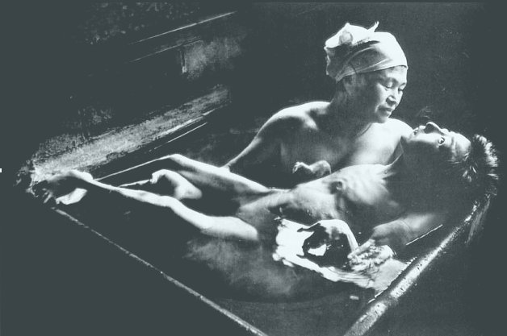

W. Eugene Smith
Tomoko Uemura in Her Bath
Minamata, 1972

