Level-3 Organometallics L8b
Metal-metal bonded compounds

Carbonyl clusters
Many thousands of examples known. Contain metal atoms in low oxidation states (zero or below). Ligands are invariably π-accpetor ligands CO, PR₃, NO C₅H₅ etc .

Compounds are either neutral molecules or anionic. Virtually NO examples of cationic clusters

Number of metal atoms range from two upwards .....
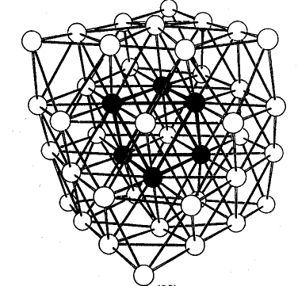

[Ni₃₈Pt₆(CO)₄₄H_{n}]⁴⁻ (CO ligands not shown)

This "cherry cluster" models a small metal particle with chemisorbed ligands - useful in understanding mechanisms of heterogeneous catalysis

