Level-3 Organometallics L8a
Metal-metal bonded compounds

References : S/A pp 302-307 & 572-579
H/S pp 592-601 E/S Ch 16
Transition metals form three main classes of metal-metal bonded compounds
- Multiple bonded dimetal complexes (Dr Murrie)
- Halide/oxide clusters
- Carbonyl clusters

Halide/oxide clusters formed by early transition metals Nb, Ta, Mo, W, Re. Have halides and/or oxides as main (often only) ligands.

Examples of earliest known cluster compounds
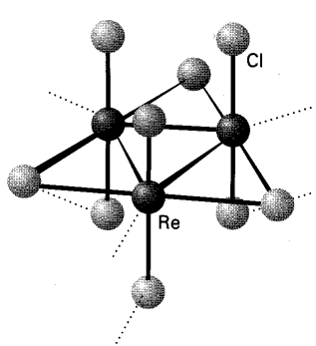
EXAMPLES

"ReCl₃" is really Re₃Cl₉

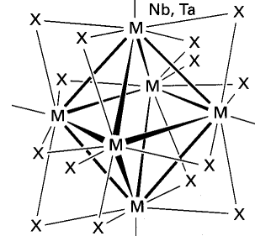
"NbCl₂" really contains [Nb₆Cl₁₂]²⁺
(chlorides bridge all edges)

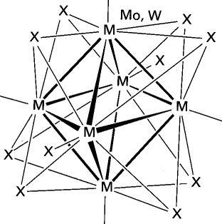
"MoCl₂" really contains [Mo₆Cl₈]⁴⁺
(chlorides bridge all faces)

