Level-3 Organometallics L7d
Metal hydride complexes
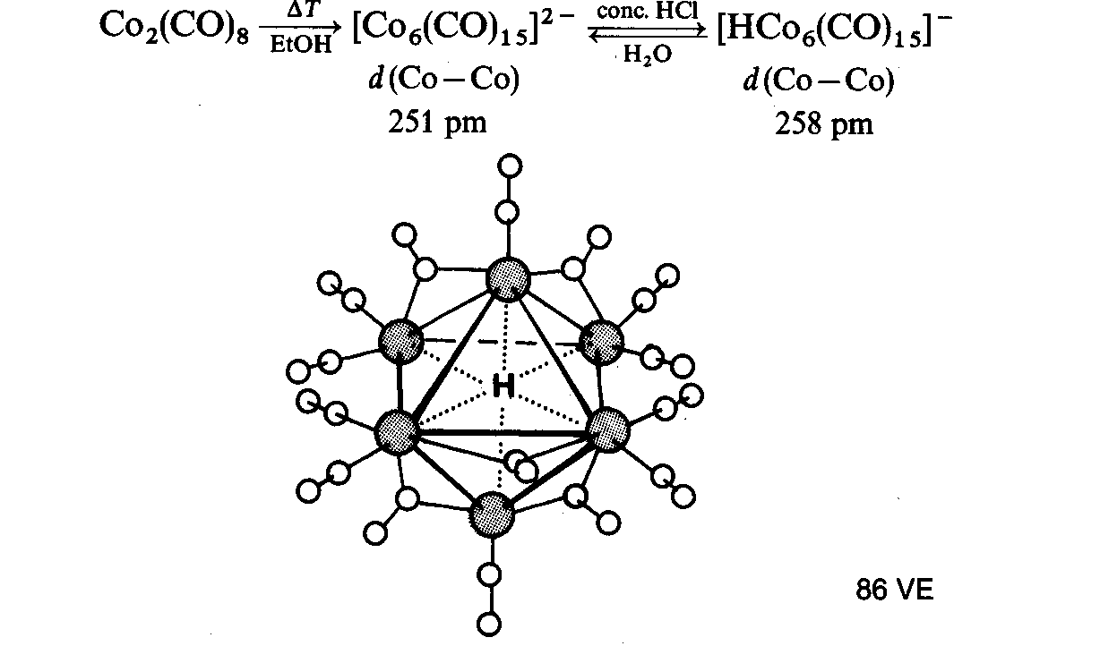
[HCo₆(CO)₁₆]⁻

4. Polyhydrides - many examples with Mo and W. Have unusual properties - very fluxional

e.g. WH₆(PR₃)₃ RuH₄(PR₃)₃

Because of small size, it is possible to pack several hydrides round metals in bimetallic polyhydrides
Ru≡R triple bond
Cp₂Ru₂H₄ Ru-Ru = 2.46 Å
normal Ru-Ru = ~ 2.9 Å

Some polyhydrides contains dihydrogen ligands

