Level-3 Organometallics L7a
Metal hydride complexes

KReO₄ + K/EtOH → "K₂Re" white crystalline solid

Modern techniques X-ray, NMR not available. Compound actually contains the anion [ReH₉]²⁻ - an 18 electron complex !!
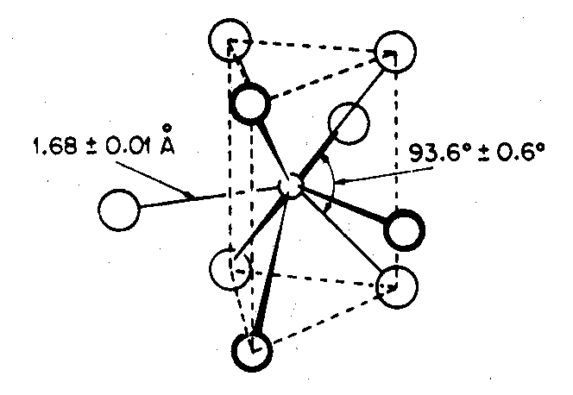
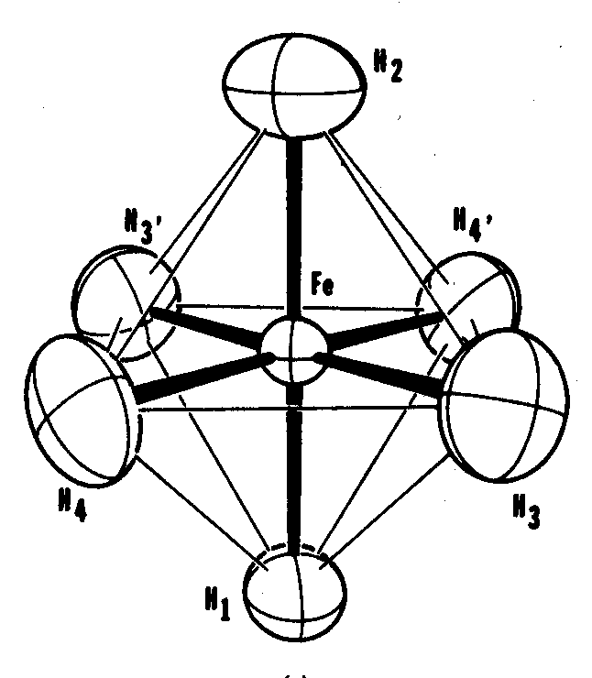

Only other well characterised pure hydride complex is Mg₂FeH₆
contains octahedral [FeH₆]⁴⁻ also 18 electron compound

Most hydride complexes contain other ligands, usually π-acceptor ligands like CO, C₅H₅ or phosphine PR₃

Earliest examples made by protonation of metal carbonylate anion.
Commonest way of making hydrides.

EXAMPLES
[Mn(CO)₅]⁻ + H⁺ → HMn(CO)₅ volatile yellow liquid δ(¹H) -7.5
stable at 0ºC
[Fe(CO)₄]²⁻ + 2H⁺ → H₂Fe(CO)₄ decomp -10ºC δ(¹H) -11.1
↓
Fe₃(CO)₁₂

