Level-3 Organometallics L7a
Metal hydride complexes

KReO₄ + K/EtOH → "K₂Re" white crystalline solid

Modern techniques X-ray, NMR not available. Compound actually contains the anion [ReH₉]²⁻ - an 18 electron complex !!
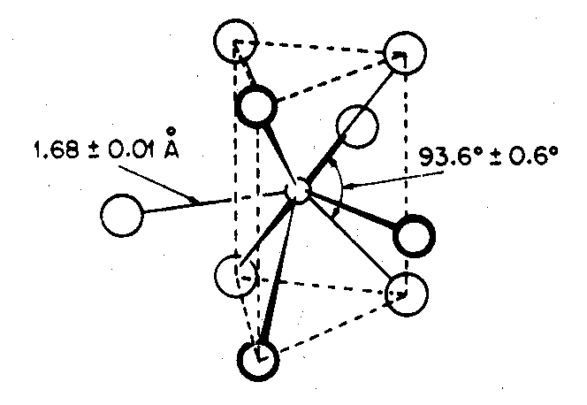
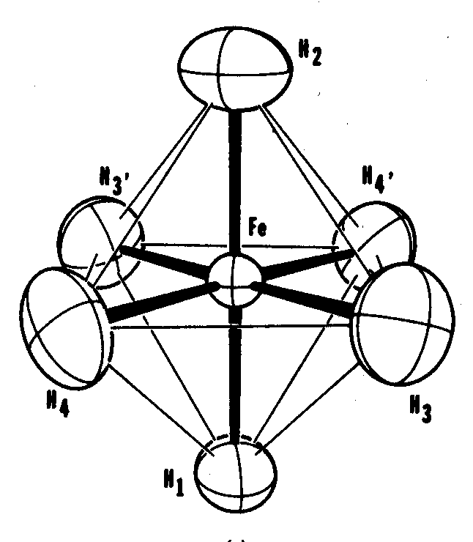

Only other well characterised pure hydride complex is Mg₂FeH₆
contains octahedral [FeH₆]⁴⁻ also 18 electron compound

Most hydride complexes contain other ligands, usually π-acceptor ligands like CO, C₅H₅ or phosphine PR₃

Earliest examples made by protonation of metal carbonylate anion.
Commonest way of making hydrides.

EXAMPLES
[Mn(CO)₅]⁻ + H⁺ → HMn(CO)₅ volatile yellow liquid δ(¹H) -7.5
stable at 0ºC
[Fe(CO)₄]²⁻ + 2H⁺ → H₂Fe(CO)₄ decomp -10ºC δ(¹H) -11.1
↓
Fe₃(CO)₁₂
Level-3 Organometallics L7b
Metal hydride complexes

How to detect metal-hydrides ?

- The negative chemical shifts in ¹H NMR are very diagnostic - no other type of H found here. Shielding due to non-local paramagnetic contribution from metal.

Terminal M-H δ -5 → -15 ppm
Bridging M-H-M δ -10 → -30 ppm

- M-H stretch in IR at ~ 2000 cm⁻¹ . Only CO stretches found in this region. M-H stretch first detected in Cp₂ReH.

For bridging hydrides M-H-M stretch is ~ 1600 cm⁻¹ and very weak and broad.

- Diffraction. X-ray not a lot of good since H atoms do not have much electron density.
Neutron diffraction much better - but serious drawbacks
(i) need neutron source - nuclear reactor
(ii) need very large crystals - difficult to grow
Level-3 Organometallics L7c
Metal hydride complexes

How are hydrides coordinated to metals ?

1. Terminal hydrides - normal coordination geometries
HMn(CO)₅

2. Bridging hydrides - very common in bimetallic and cluster compounds
[HFe₂(CO)₈]⁻

Has 3c-2e bond like B-H-B bond in boranes. This type of bonding has the effect of
- weakening Fe-Fe bond - longer than in [Fe₂(CO)₈]²⁻
- lowers metal-H stretch to ~ 1700 - 1500 cm⁻¹

3. Encapsulated hydrides - completely inside metal cage
[HCo₆(CO)₁₅]⁻ CW/5 p 1111 E/S p 408
δ(¹H) +23 ppm
Level-3 Organometallics L7d
Metal hydride complexes
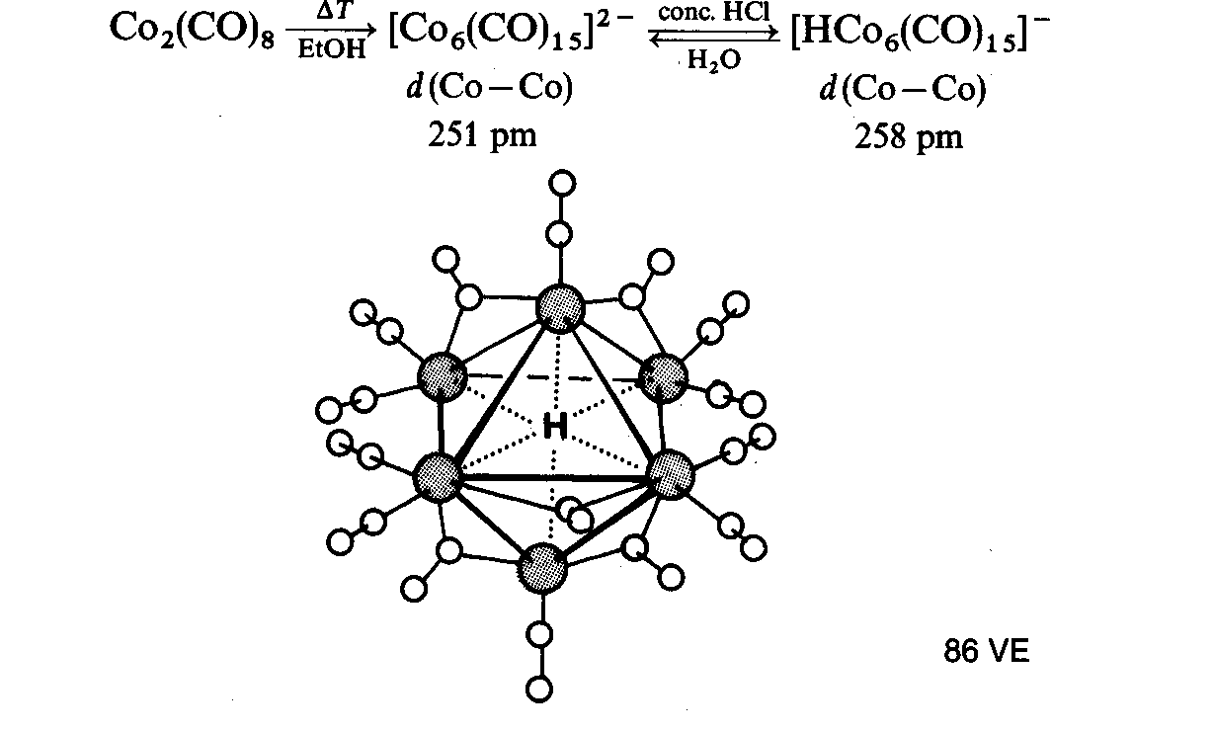
[HCo₆(CO)₁₆]⁻

4. Polyhydrides - many examples with Mo and W. Have unusual properties - very fluxional

e.g. WH₆(PR₃)₃ RuH₄(PR₃)₃

Because of small size, it is possible to pack several hydrides round metals in bimetallic polyhydrides
Ru≡R triple bond
Cp₂Ru₂H₄ Ru-Ru = 2.46 Å
normal Ru-Ru = ~ 2.9 Å

Some polyhydrides contains dihydrogen ligands
Level-3 Organometallics L7e
Metal dihydrogen complexes
RuH₄(PR₃)₃ is actually

most examples of dihydrogen compounds are octahedral

Bonding has σ-donation and π-backdonation components. Most important is σ-donation. Too much π-backdonation leads to breaking of H-H bond giving cis dihydride

How to characterise dihydrogen ligands ?

1. Diffraction
Neutron diffraction is definitive way - but not always possible to get suitable crystals
Level-3 Organometallics L7f
Metal dihydrogen complexes

2. Spectroscopic characterisation

In IR, the H-H stretch should give weak absorption at ~2400cm⁻¹

FeH₄(PEtPh₂)₃ has H-H 2380 cm⁻¹
and Fe-H 1880 cm⁻¹
but in RuH₄(PPh₃)₃ Ru-H 1942 cm⁻¹
H-H obscured

¹H NMR spectroscopy is better. Due to fluxionality it is NOT possible to see separate signals for H₂ and hydride ligands

Use the T₁ (relaxation time) criterion.
For hydrogen nuclei, relaxation is solely by dipole-dipole interactions with other H atoms
T_{1 ∝} r ⁶ (r is average H-H distance)

This is shorter for H₂ ligands H-H ~ 1.0Å
than for cis - dihydrides where H-H ≥ 1.6 Å

EXAMPLE for MH₄(PPh₃)₃ complexes (M=Fe, Ru, Os)
 | Fe | Ru | Os
T₁ (ms) | 24 | 38 | 820

Conclusion : Osmium compound contains classical hydrides, other two contain dihydrogen ligands.

