Level-3 Organometallics L4d

M-C bonding in CO complexes
There are three components to the bonding between CO and TM

(i) σ-donation from CO σ* level (5σ)
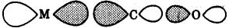
empty filled
M(σ) ← CO(5σ)

(ii) π-donation from CO 1π
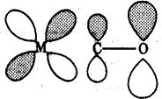
empty filled
M(π) ← CO(1π)

(iii) π-acceptor from metal to CO 2π*
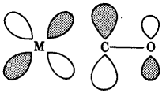
filled empty
M(π) → CO(2π*)

