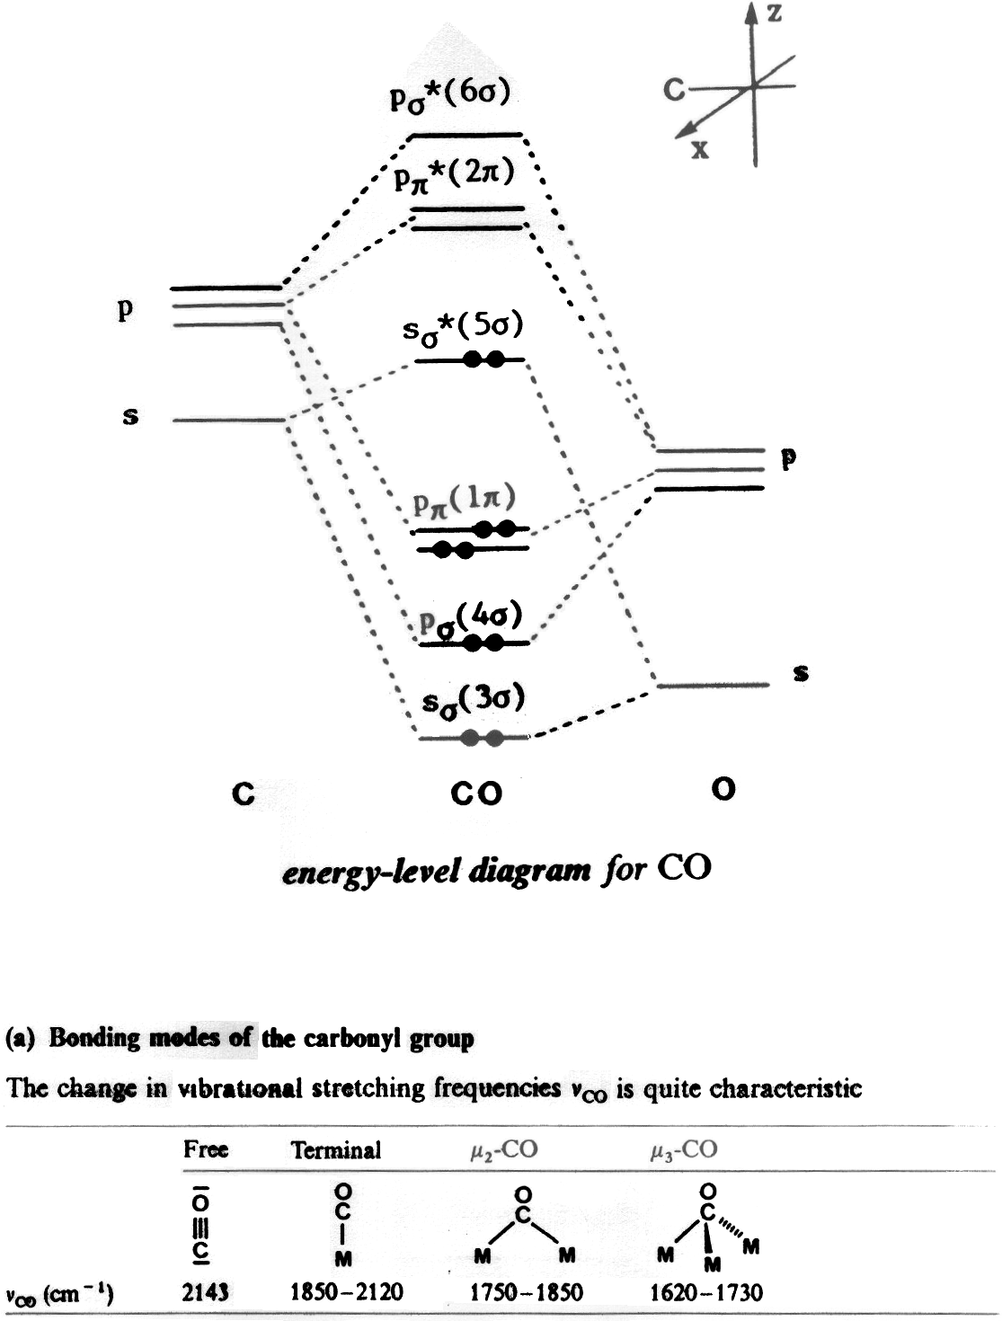
Level-3 Organometallics L4c

