Level-3 Organometallics L4a

Complexes with unsaturated alkyl groups

Some alkyl groups have unsaturated functionality next at the α-C atom

These have possibility for π-bonding to metal atom. Structural evidence suggests this is not happening.

EXAMPLE trans-PtCl(PPhMe₂)₂R

obs Pt-C (Å) calc Pt-C (Å)
CH₂SiMe₃ 2.08 2.01
CH=CH₂ 2.03 1.98
C≡CPh 1.98 1.91

Unsaturated functionality can be bonded to another metal. example below is a bridging vinyl group

Level-3 Organometallics L4b

Complexes with π-acceptor ligands

There are many of these type of ligand (E/S Ch 15 S/A Ch 16)
Some bond to metal through one atom - described as η¹ (eta-one)
ligands, while others (described later) bind through more than one.

Examples of η¹ ligands

M-CO | M-PR₃ | M-CNR | M=CR₂ | M≡CR | M-CS | M-NO
carbonyl | phosphine | isocyanide  isonitrile | carbene  alkylidene | carbyne  alkylidyne | thiocarbonyl | nitrosyl

Conveniently classed together because bonding to TM is very similar in all cases - involves synergic bonding also called back-bonding

Evidence for back-bonding (E/Salzer pp 226-231)
- bond lengths increases the strength, hence reduces the length of M-C bond but decreases the strength, hence increases the length of the C-O bond. Not easy to see latter.
- C-0 stretching frequencies - this is very sensitive to extent of backbonding. For neutral (i.e. uncharged) complexes the range of frequencies allows distinction between terminal bridging and triply-bridging bonding
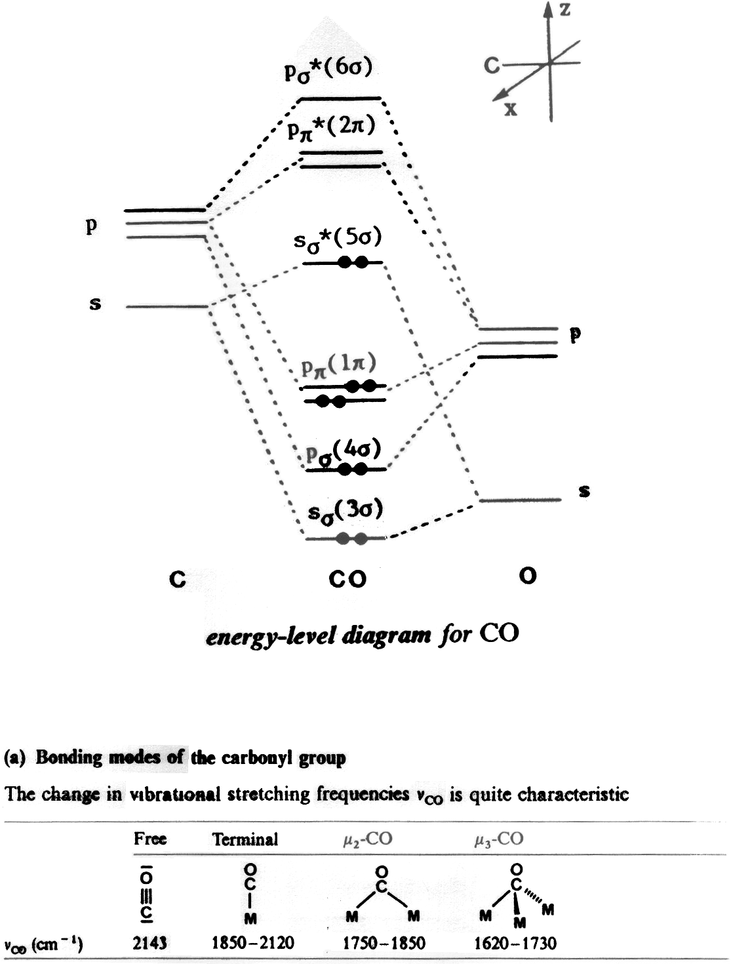
Level-3 Organometallics L4c

Level-3 Organometallics L4d

M-C bonding in CO complexes
There are three components to the bonding between CO and TM

(i) σ-donation from CO σ* level (5σ)

empty filled
M(σ) ← CO(5σ)

(ii) π-donation from CO 1π
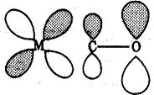
empty filled
M(π) ← CO(1π)

(iii) π-acceptor from metal to CO 2π*
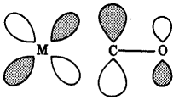
filled empty
M(π) → CO(2π*)
Level-3 Organometallics L4e

M-C bonding in CO complexes – the actual orbitals
