Level-3 Organometallics L3c

Synthesis of stable metal alkyl compounds

(4) Oxidative addition of alkyl halide to 16 e⁻ complex
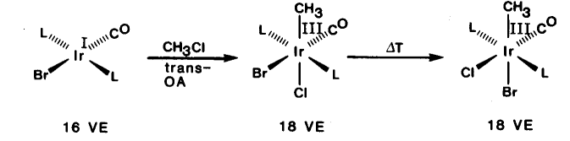
Many 16 e⁻ compounds with a d ⁸ or d ¹⁰ configuration react with alkyl halides

Metals undergo change of +2 in oxidation level. Very common for square-planar d ⁸ complexes

square-planar Rh(+1) Pd(+2) Pt(+2)
goes to octahedral Rh(+3) Pd(+4) Pt(+4)

Oxidative addition requires :
- metal has two accessible oxidation states differing by +2
- metal has vacant coordination sites

Also possible for zerovalent d ¹⁰ compounds
