Level-3 Organometallics L3a

Synthesis of stable metal alkyl compounds

(2) Metal hydride plus alkene

This is the reverse of the β-elimination reaction and is an example of the general insertion reaction. These involve insertion of small molecules into transition metal-X bonds. In this case that of an alkene into a TM-H (hydride) bond.

EXAMPLE
trans-(Et₃P)₂PtHCl + C₂H₄ → trans-(Et₃P)₂PtCl(C₂H₅)

In this example the resulting ethyl complex is stable because the d ⁸ platinum Pt(2+) atom strongly prefers square-planar geometry.

A related route is insertion of a carbene into a TM-H bond

EXAMPLE
CpMo(CO)₃H + CH₂N₂ → CpMo(CO)₃(CH₃)

CH₂N₂ is diazo-methane - an unstable molecule which acts as a source of the reactive intermediate "CH₂"
Level-3 Organometallics L3b

Synthesis of stable metal alkyl compounds

(3) Metal based nucleophile plus alkyl/acyl halide

This is closely related to the nucleophilic displacement reaction in organic chemistry
Nu⁻ + RX → NuR + X⁻

The nucleophile used are metal centered nucleophiles and are electron rich TM compounds. The most commonly used are metal carbonylate anions. Made with strong reducing agents such as sodium amalgam (Na/Hg)

EXAMPLE
Mn₂(CO)₁₀ + Na/Hg → 2 Na⁺ [Mn(CO)₅]⁻

Cleave Mn-Mn bond and reduce Mn to Mn(-1)

Na⁺ [Mn(CO)₅]⁻ + CH₃I → CH₃Mn(CO)₅

EXAMPLE
[CpFe(CO)₂]₂ + Na/Hg → Na⁺ [CpFe(CO)₂]⁻

C₂H₅I → CpFe(CO)₂(C₂H₅)
CH₃COCl → CpFe(CO)₂C(O)CH₃
acyl complex
Level-3 Organometallics L3c

Synthesis of stable metal alkyl compounds

(4) Oxidative addition of alkyl halide to 16 e⁻ complex
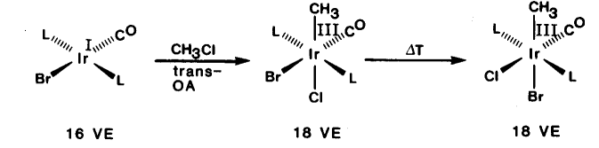
Many 16 e⁻ compounds with a d ⁸ or d ¹⁰ configuration react with alkyl halides

Metals undergo change of +2 in oxidation level. Very common for square-planar d ⁸ complexes

square-planar Rh(+1) Pd(+2) Pt(+2)
goes to octahedral Rh(+3) Pd(+4) Pt(+4)

Oxidative addition requires :
- metal has two accessible oxidation states differing by +2
- metal has vacant coordination sites

Also possible for zerovalent d ¹⁰ compounds
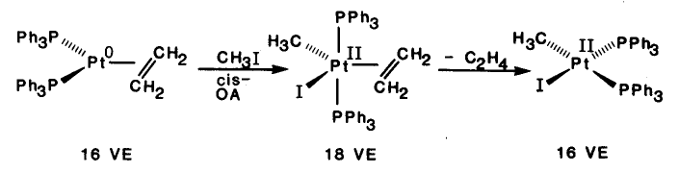
Level-3 Organometallics L3d

Reactions of metal alkyls

(1) Decomposition
Main route is by β-elimination. Experimental evidence to support mechanism :
- from labelling studies it is proved that β-hydrogen is transferred
(Bu₃P)CuCH₂CD₂Et → "(Bu₃P)CuD" + CH₂=CDEt
not detected
CH₂DCD₂Et

- necessity of vacant coordination site shown by inhibition of reaction with added PPh₃
CpFe(alkyl)(CO)(PPh₃) → CpFeH(CO)(PPh₃) + alkene

- best evidence comes from structures of alkyl complexes which show "agostic" interactions

Ti(dppm)Cl₂(CH₃) [CpCo(PR₃)(C₂H₅)]⁺
agostic methyl agostic ethyl

Level-3 Organometallics L3e

Reactions of metal alkyls

(1) Decomposition ......

Other routes are by α-elimination
EXAMPLE : WMe₆ → 3CH₄ + 3"W(CH₂)₃" (unknown polymer)

or by reductive elimination - reverse of oxidative addition

requires that groups eliminated are cis

(2) Insertion reaction
Many small molecules with multiple bonds (e.g. CO₂, CS₂, NO) will insert into M-C bonds. Most important is CO
EXAMPLE : (CO)₅MnCH₃ +CO→ (CO)₅MnC(O)CH₃ new acyl bond

Mechanistic studies show that
- the CO in the acyl groups comes from already coordinated CO
- incoming CO is cis to the acyl group
Level-3 Organometallics L3e

Reactions of metal alkyls

(1) Decomposition ......

Other routes are by α-elimination
EXAMPLE : WMe₆ → 3CH₄ + 3"W(CH₂)₃" (unknown polymer)

or by reductive elimination - reverse of oxidative addition

requires that groups eliminated are cis

(2) Insertion reaction
Many small molecules with multiple bonds (e.g. CO₂, CS₂, NO) will insert into M-C bonds. Most important is CO
EXAMPLE : (CO)₅MnCH₃ +CO→ (CO)₅MnC(O)CH₃ new acyl bond

Mechanistic studies show that
- the CO in the acyl groups comes from already coordinated CO
- incoming CO is cis to the acyl group

