(Invited paper of the CompComm Newsletter No.5, January 2005)
DIMS on the VEC platform

Fan, Hai-fu
Institute of Physics, Chinese Academy of Sciences, Beijing 100080, P. R. China
Email: fan@mail.iphy.ac.cn

- Introduction
DIMS is a Direct-method program of solving Incommensurate Modulated Structures or, it can also be regarded as a program of Direct methods In Multidimensional Space (Fu et al., 1994, 1997; Li et al., 1999). DIMS is based on the multidimensional direct methods developed in our research group in Beijing (Hao et al., 1987; Fan et al., 1993; Sha et al., 1994; Mo et al., 1996) and the Rantan phasing procedure developed in Professor M.M. Woolfson’s group in York, England (Yao, 1981). The program is for solving one-dimensionally modulated incommensurate structures and composite structures consists of two subsystems with two axes of the unit cell coincided to each other. For incommensurate modulated structures, DIMS can deal with diffraction data from X-rays, electrons or neutrons, while for composite structures only X-ray diffraction data are considered. There are two versions of DIMS in VEC (Wan et al., 2003). One is merged with other VEC functions, while the other is stand-alone. Both can be invoked on the VEC platform. The former is used for image processing in electron microscopy, while the latter is used for ab-initio determination of incommensurate modulated and composite structures. The latter is to be described here. More details of both DIMS and VEC can be found on the web site http://cryst.iphy.ac.cn. Executives of DIMS and VEC and the source codes of DIMS are also available there.

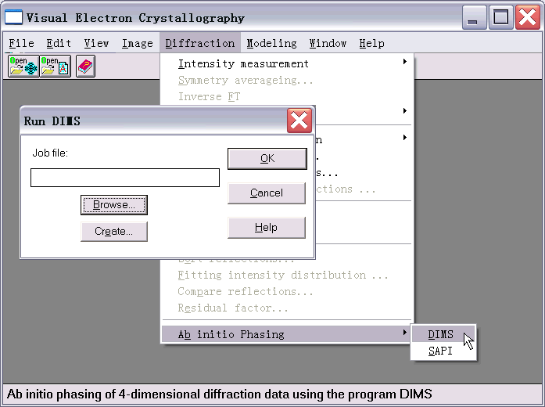
- Invoking DIMS and preparing the input file
Figure 1
Run the program VEC first, then pull down the menu "Diffraction", select "Ab initio Phasing" and then select "DIMS". This brings up the dialog box "Run DIMS" asking the user to supply a Job file (input file). Click "Browse" to locate the Job file or click "Create" to make a new one (see Fig. 1). The input file is a text file, which can be created either by following the dialog boxes or by using a text editor. A typical input file is shown in Fig. 2. Keywords used in the input file are given in the Appendix. For the meaning of a particular keyword, please click on that keyword in Fig. 2.

- The output files
Three output files are produced by DIMS. They are *.OUT1, *.OUT2 and *.hklm. The first one (*.OUT1) is actually a log file. The second (*.OUT2) is a file containing only experimental structure-factor magnitudes and their phases derived by DIMS. These two files are originally used with the UNIX/DOS version of DIMS. The only output file used on the VEC platform for further calculations is the third one (*.hklm). Once this file has been created by DIMS, it will be opened automatically in graphic mode on the VEC platform in a sub-window (see the upper-left sub-window in Fig. 4). Further calculations can then be performed on it. The file can also be opened in text mode on the VEC platform for inspection and editing.

Figure 2. The input file Na2CO3.key
- Calculation and display of 4D electron-density maps
g-Na2CO3
C STATUS ORDER PATH VOID1
0 2 3 0
C NTRIAL SKIP VOID2 RANTP
20 0 0 1
C NFS0 NFS1 NFS2 NFS3 NFS4 NFS5 NFS6
0 0 0 0 0 0 0
C ZP0 ZP1 ZP2 ZP3 ZP4 ZP5 ZP6
0 0 0 0 0 0 0
C CLCTR MAXCL NCLFIX RADIUS
0.005 1 1 0
C W1 W2 W3
0.20 1.40 1.40
C MAXREL KPMIN KPMAX PPERC
300 1.0 50.0 1.0
C A1 B1 C1 ALPHA1 BETA1 GAMMA1
8.9040 5.2390 6.0420 90.000 101.350 90.000
C A2 B2 C2 ALFA2 BETA2 GAMA2
0.0000 0.0000 0.0000 90.000 90.000 90.000
C K1 K2 K3
0.1820 0.0000 0.3180
C NOIN NORMAL STATIS BFACTOR NWLSTEP
1 1 1 0.00 16
C NUMBER ATOMIC NR ELEMENT (CELL CONTENTS)
8 11 Na
4 6 C
12 8 O
0 0
C SPACE-GROUP SYMBOL OR GENERATORS
P[C 2/M] -1 S :B
C DIFFACTION DATA
h k l m F(obs) Phase KN
0 0 2 0 61.300 180.000 1
0 0 4 0 54.500 0.000 1
0 0 5 0 2.400 180.000 1
0 0 7 0 2.700 0.000 1
0 0 8 0 12.000 0.000 1
. . .
. . .
. . .
1 5 0 2 0.100 0.000 0
3 5 3 2 0.100 0.000 0
7 5 1 2 0.100 0.000 0
0 0 0 0 -99.900 0.000 0
Projections and sections of 4-dimensional electron–density maps can be calculated on the VEC platform using the DIMS output file *.hklm.
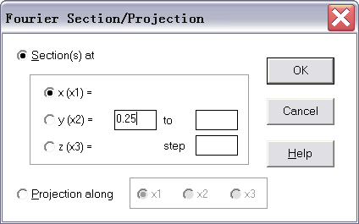
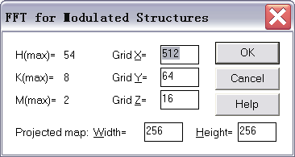
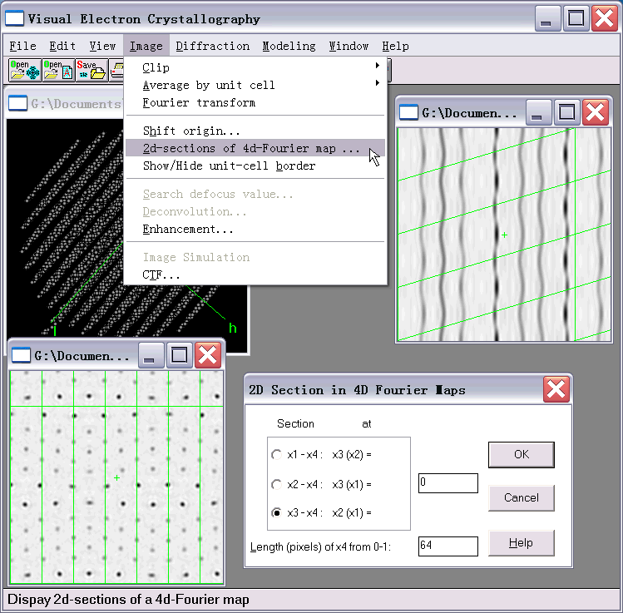
Example 1. Using the file Bi-2212.hklm to calculate an x₃ − x₄ section ρ (0.25, 0.00, x₃, x₄), the user should first calculate a 3-dimensional hyper-section at x₁ = 0.25. Open the *.hklm file in graphic mode or activate the sub-window containing the file. Then click the button on the toolbar. This will bring up the dialog box shown in Fig. 3a, choose 'Sections' and set x₁ = 0.25. After clicking “OK” another dialog box will appear as is shown in Fig. 3b. Usually there is no need to change any thing in this dialog box; the user can just click “OK” to pass. This will result in a 3-dimensional hyper-section x₁ = 0.25 of the 4-dimensional electron-density map. The hyper-section is stored in the disk of the computer. What you see on the screen (the lower-left sub-window in Fig. 4) is only a 2-dimensional section with the first unit cell on the left corresponding to ρ (0.25, x₂, x₃, 0.00). The green lines are unit-cell borders, which are displayed or eliminated by clicking the item “Show/Hide unit-cell border” on the pull-down menu of “Image” (see upper middle of Fig. 4). Unit cells next to the left first one will have different x₄ values according to the 4-dimensional representation of 1-dimensionally incommensurate modulated structures. Operations on this window are not with the 2-dimensional section on the screen but with the 3-dimensional hyper-section in the disk. Now, activate the window and select the item “2d-sections of 4d-Fourier map” on the pull-down menu “Image”. In the pop-up dialog box (lower right of Fig. 4), select the x3-x4 section and set x2 = 0. Then by clicking “OK” the section ρ (0.25, 0.00, x₃, x₄) will be obtained (see the upper-right sub-window in Fig. 4).
Figure 3
(a)
(b)
Figure 4
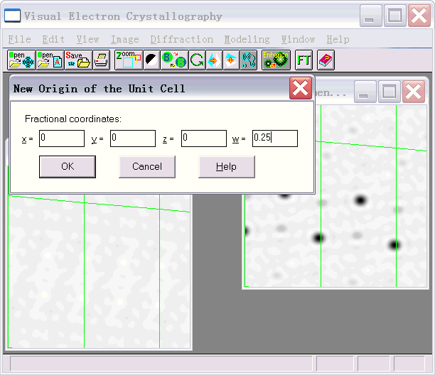
Example 2. Using the file PbTiS.hklm to calculate an x₂ − x₃ section ρ (0.25, x₂, x₃, 0.25), the user should first calculate a 3-dimensional hyper-section at x₁ = 0.25. The operation is the same as that in the previous example. The result is shown in the lower-left sub-window of Fig. 5. Now, pull down the “Image” menu and click on the item “Shift origin” (see upper middle of Fig. 4). In the pop-up dialog box (see the upper-left corner of Fig. 5) set the fractional coordinates x = 0, y = 0, z = 0 and w = 0.25. Then the section ρ (0.25, x₂, x₃, 0.25) will come up as is shown in the upper-right sub-window of Fig. 5.
Figure 5
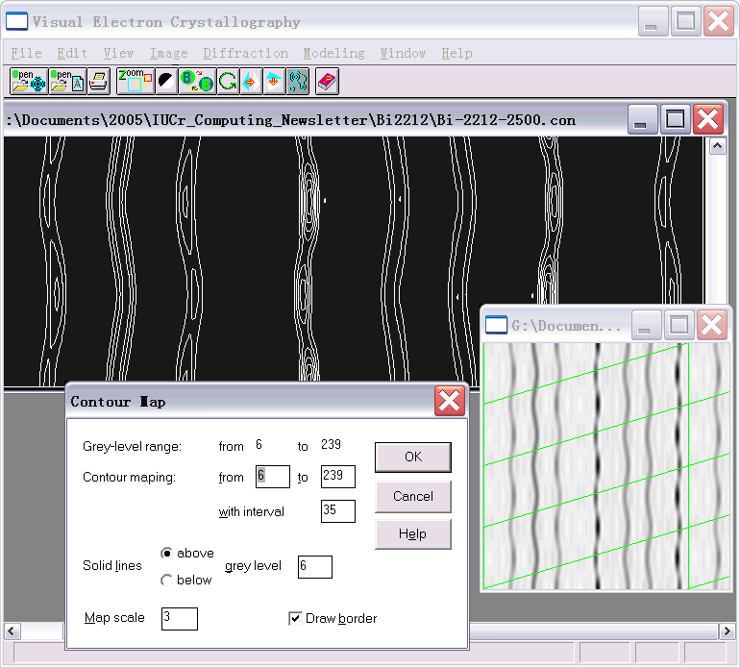
Electron-density maps are displayed by default as half-tone graphs. However they can also be displayed as contour maps. To do this, click on the half-tone graph (lower right of Fig.6) and then click the button on the toolbar. Tune the parameters on the pop-up dialog box (lower left of Fig. 6) and click “OK”. The corresponding contoured map will then appear (see upper part of Fig. 6).
Figure 6

- 4D model building
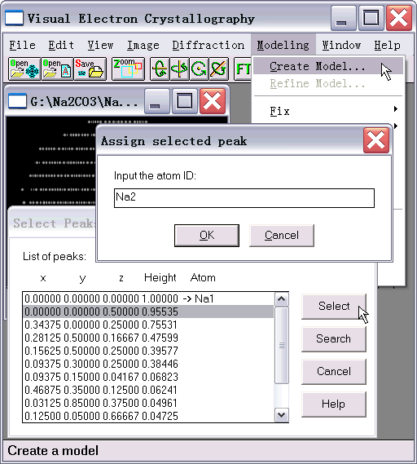
Starting from the *.hklm file, here we use the file Na2CO3.hklm, click on the pull-down menu “Modeling” and select “Create Model” (see upper right of Fig. 7). This starts searching for atoms in the 3-dimensional basic structure. When a DOS window appears, press “Enter” to continue. A peak list containing the searching results will appear as shown in the lower part of Fig. 7. The user should assign atom IDs to a set of symmetrically independent peaks. To do this, highlight the peak, click the button “Select” on the peak-list table, then input an atom ID into the pop-up dialog box as shown in the middle of Fig. 7. The atomic ID is the chemical symbol of the element. Optional characters (no spaces) can be added following the symbol. Having finished assigning atom IDs, click the button “Search”. This starts the search of the modulation wave of each atom. Results will be listed in the model file Na2CO3.mod, which will be opened automatically and graphically in a sub-window (see the lower part of Fig. 8). The model file can be saved in the disk as a text file; it contains information for starting a least-squares refinement.
Figure 7
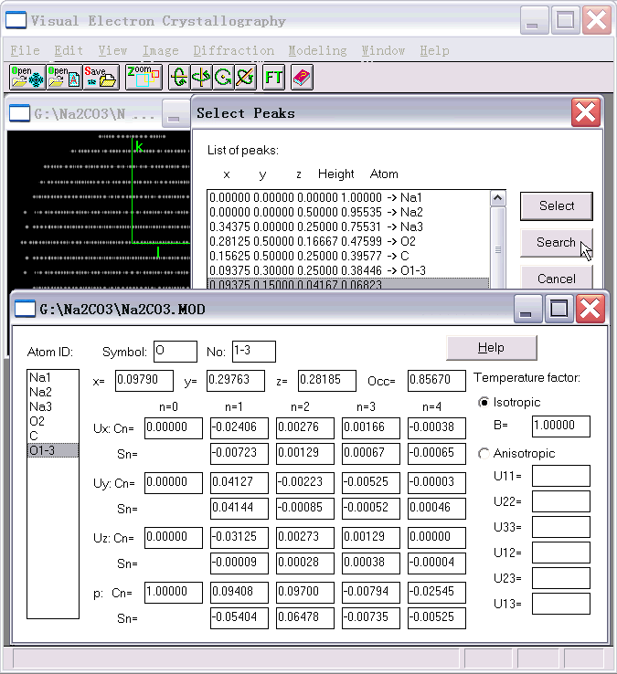
Figure 8

References

Fan, H.F., van Smaalen, S., Lam, E.J.W. & Beurskens, P.T. (1993). Direct methods for incommensurate intergrowth compounds I. Determination of the modulation. Acta Cryst. A49, 704-708.
Fu, Z.Q. & Fan, H.F. (1994). DIMS --- a direct method program for incommensurate modulated structures. J. Appl. Cryst., 27, 124-127.
Fu, Z.Q. & Fan, H.F. (1997). A computer program to derive (3+1)-dimensional symmetry operations from two-line symbols. J. Appl. Cryst., 30, 73-78.
Hao, Q., Liu, Y.W. & Fan, H.F. (1987). Direct methods in superspace I. Preliminary theory and test on the determination of incommensurate modulated structures. Acta Cryst., A43, 820-824.
Li, Y., Wan, Z.H. & Fan, H.F. (1999). MIMS — a program for measuring 4-dimensional Fourier maps of incommensurate modulated structures. J. Appl. Cryst.,32, 1017-1020.
Mo, Y.D., Fu, Z.Q., Fan, H.F., van Smaalen, S. Lam, E.J.W. & Beurskens, P.T. (1996). Direct methods for incommensurate intergrowth compounds III. Solving the average structure in multidimensional space. Acta Cryst. A52, 640-644.
Sha, B.D., Fan, H.F., van Smaalen, S., Lam, E.J.W. & Beurskens, P.T. (1994). Direct methods for incommensurate intergrowth compounds II. Determination of the modulation using only main reflections. Acta Cryst. A50, 511-515.
Wan, Z.H., Liu, Y.D. Fu, Z.Q., Li, Y., Cheng, T.Z., Li, F.H. & Fan, H.F. (2003). Visual computing in electron crystallography. Z. Krist. 218, 308-315.
Yao, J. X. (1981). On the application of phase relationships to complex structures XVIII. RANTAN—Random MULTAN. Acta Cryst., A37, 642-644.

Appendix − Keywords for running DIMS

The first line:
A title with no effects to the phasing process

STATUS (default = 0)
0: for unknown structures
1: for known structures, comparison will be made between the phases of satellite reflections input by the user and that derived by DIMS.

PATH (default = 3)
1: for phasing the satellites of incommensurate structures with known phases of the main reflections, the weak-weak relationships are used such that the newly obtained phases of the n^{th}-order satellites are taken as known phases for phasing the (n+1)^{th}-order satellites. Only one of the 1st-order satellites is assigned a 'known' phase ZP1 to determine the origin of the 4th axis.
2: for phasing the satellites of incommensurate structures with known phases of the main reflections, the weak-weak relationships are neglected for phasing all the satellites. One of each n^{th}-order satellites is assigned a 'known' phase in the phasing procedure. Values of these phase angles are specified under the keyword ZPn.
3: for phasing the satellites of incommensurate structures with known phases of the main reflections, the satellites with order greater than 1 are phased using PATH=2 and then weak-weak relationships are used to determine the origin-depending phase shift.
4: for phasing composite structures, the weak-weak relationships are neglected.

ZPn
The phase angle of an n^{th}-order satellite, which is used as the origin-fixing reflection for phasing the n^{th}-order satellites.

ORDER (default = 2)
0: phasing for main reflections based on certain known phases of main reflections.
> 0: for PATH = 1, 2 or 3, up to ORDER^{th}-order satellites will be phased with known phases of main reflections.
128: for PATH = 4, only main reflections will be phased.
129: for PATH = 4, all satellites will be phased with known phases of main reflections and, the weak-weak relationships will be neglected.

RANTP (default = 0) active only for acentric space group with PATH = 4
0: random phases of 45/135/225/315 degrees are assigned
1: random phases of 0/180 degrees are assigned

RADIUS (default = 0)
0: input phases in degree.
1: input phases in radius.

MAXREL (default = 300)
Maximum number of Σ₂ relations allowed for a single reflection.

KPMAX (default = 50.0)
Σ₂-relations with kappa greater than KPMAX will be eliminated.

KPMIN (default = 0.0)
The value of this parameter ranges from 0.0 to 2.0, which is for eliminating Σ₂-relations with kappa less then KPMIN.

PPERC (default = 1.0)
PPERC×100 % reflections (selected from the strongest one downward) will be phased, active only when phasing main reflections of composite structures (PATH=4, ORDER=128).

NTRIAL (default = 50)
Number of trials, i.e. the number of random-starting phase sets (max. NTRIAL = 1024).

SKIP (default = 0)
Skip the first SKIP trials.

NFSn (n = 0, 1, ..., 6)
> = 0: output phases will contain up to n^{th}-order satellites, the output phase sets are selected according to the combined figures of merit CFOM.
< 0: The absolute value under the keyword NFSn will be the serial number of the set that you want to output disregarding the value of CFOM.

CLCTR (default = 0.005)
A parameter controlling dynamically the number of cycles of phase iteration

MAXCL (default = 10)
the maximum number of cycles allowed for tangent-formula iteration

NCLFIX (default = 6)
In the first NCLFIX cycles of tangent-formula iteration the known phases are kept fixed, after that they are floatable.

A1, B1, C1, ALPHA1, BETA1, GAMMA1
Unit-cell parameters of the basic structure of the incommensurate modulated structure, or of the first subsystem of the composite structure.

A2, B2, C2, ALPHA2, BETA2, GAMMA2
Unit-cell parameters of the second subsystem of the composite structure.

K1, K2, K3
The a*, b* and c* components of the modulation wave vector
q = k₁a* + k₂ b* + k₃ c*

W1 (default = 0.2), W2 (default = 1.4), W3 (default = 1.4)
Weights of the figures of merit ABSFOM, PSI-ZERO and RISIDUAL in the calculation of the combined figure of merit CFOM

NOIN
In the cell contents, the top NOIN chemical elements belong to the first subsystem of the composite structures, active only when phasing main reflections of composite structures (PATH=4 and ORDER=128).

NORMAL (= 0 or 1)
Indicates one of the two strategies for scaling Fobs, active only when PATH=4 and ORDER=128.

STATIS
0: no WILSON statistics will be performed
1: WILSON method is used to scale Fobs
2: K-curve method is used to scale Fobs, active only when PATH=4 and ORDER=128.

BFACTOR
0.0: the B-factor from WILSON statistics is used for scaling, else: BFACTOR is used instead of the B-factor from WILSON statistics; active only when PATH=4, ORDER=128 and STATIS=1.

NWLSTEP (default = 16)
For the WILSON statistics, the reciprocal space will be divided in NWLSTEP zones.

ELEMENT
Chemical symbol of atoms in the unit cell.

ATOMIC NR
Atomic number of the specified chemical element

NUMBER
Number of atoms in the cell

SUPERSPACE GROUP: TWO-LINE SYMBOL or GENERATORS
The superspace-group symmetry is expressed either by a two-line symbol or a set of generators.
As an example the two-line symbol for the incommensurate modulated structure of γ -Na₂CO₃ is

P[C 2/M]-1 S :B
For more details, the user is referred to Fu Zheng-qing & Fan Hai-fu (1997) "A computer program to derive (3+1)-dimensional symmetry operations from two-line symbols" J. Appl. Cryst. 30, 73-78.

If generators are to be used, the user should first specify the number of generators before listing the elements of the first generator. Each generator should be ended with a blank line. As an example the generators for γ -Na₂CO₃ not including operations of the centered lattice are expressed as

2
-1 | 0 | 0 | 0 | 0.0000
0 | 1 | 0 | 0 | 0.0000
0 | 0 | -1 | 0 | 0.0000
0 | 0 | 0 | -1 | 0.5000
1 | 0 | 0 | 0 | 0.0000
0 | -1 | 0 | 0 | 0.0000
0 | 0 | 1 | 0 | 0.0000
0 | 0 | 0 | 1 | 0.5000

KN
Indicates the preceding phase is known or not

0: unknown, its value is to be derived, the listed value will NOT take part in the derivation, however in the case of STATUS = 1 the listed phases will be compared with that derived from DIMS.
1: known, it will be used as starting phase to derive unknown phases.
2: a random phase will be assigned

MK
Indicates whether the reflection will be rejected in the phasing process.
-1: rejected, a random phase will be given to this reflection in the output file.
1: not rejected.

DN
For STATUS=1, indicates the difference between the given and the derived phases.

