(Invited paper of the CompComm Newsletter No.5, January 2005)
DIMS/VEC applications

Fan, Hai-fu
Institute of Physics, Chinese Academy of Sciences, Beijing 100080, P. R. China
Email: fan@mail.iphy.ac.cn

- Introduction
The integration of DIMS (Fu et al., 1994, 1997; Li et al., 1999) and VEC (Wan et al., 2003) provides an intuitive and automatic way of solving incommensurate structures. Calculations are visually performed on the VEC platform mostly via mouse clicks. Examples are given here involving two incommensurate modulated structures and the 4-dimensional basic structure of a composite crystal. As will be seen, structural details including the incommensurate modulation can be observed objectively prior to the model building and least-squares refinement. For detailed operations of the program DIMS/VEC the reader is referred to the paper “DIMS on the VEC platform” in this newsletter.

- Direct observation of the incommensurate modulation of γ-Na₂CO₃
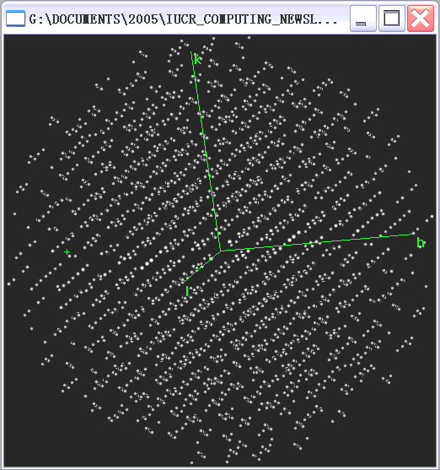
Crystals of γ-Na₂CO₃ have a one-dimensionally modulated incommensurate structure with unit cell parameters of the basic structure a = 8.904, b = 5.239, c = 6.042Å, β = 101.35º and the modulation wave vector q = 0.182a* + 0.318c*. The superspace group is P[C 2/m] –1 s (two-line symbol used in DIMS). Van Aalst et al. (1976) originally solved the modulated structure by trial-and-error method. Hao et al. (1987) used their data to test the multidimensional direct method. 300 largest main reflections, 250 largest first order satellites and 150 largest second order satellites from the experimental data were selected for the test. The program SAPI (Yao et al., 1985) was used to derive phases of main reflections, based on which the multidimensional direct method was used to phase satellite reflections. There is no need to know the basic structure in advance. In the present test, the input file Na2CO3.key was constructed with the same data used by Hao et al. (1987). The output file Na2CO3.hklm was produced and opened in a sub-window on the VEC platform (see Fig. 1). The file contains the original input data together with the direct-method phases of satellite reflections. Fig. 2 shows sections of the 4-dimensional electron density map of γ-Na₂CO₃ calculated with the file Na2CO3.hklm. The top row of Fig. 2 shows the half-tone graphic section of the 4-dimensional electron-density map at x₃ (z) = ¼. Six unit cells are plotted along the x₁ axis. Since the modulation wave vector q has a component q₁ = 0.182 along a*, the modulation period should be about 5.5 unit cells along the x₁ axis. Consequently the first unit cell on the left of the top row corresponds to x₄ = 0.0, while the sixth unit cell corresponds to x₄ ≈ 1.0. This is evident comparing the top row and the middle row, the contoured section ρ (0.15625, x₂, ¼, x₄). As is seen the top section reveals clearly sodium atoms and CO₃ groups. It is seen also that the x₂ coordinate of carbon atoms varies along the x₁ axis from one unit cell to the other indicating the positional modulation of the carbon atoms as shown by the red curve. This can be seen more precisely on the section ρ (0.15625, x₂, ¼, x₄). By comparing the second and the fifth unit cell (see the bottom row of Fig. 2), it is observed that the modulation of the CO₃ groups performs an anticlockwise rotation around the axis through the carbon atom perpendicular to the (a, b) plane (a and b are respectively the projection of x₁ and x₂ along the direction perpendicular to the 3-dimensional physical space). All these features are consistent with the original result of Van Aalst et al. (1976). One of the most important differences between DIMS/VEC and the trial-and-error method is that all features of the structural modulation of γ-Na₂CO₃ are visualized on the direct-method phased electron-density map, which does not rely on any assumptions concerning the form of modulation waves and is obtainable prior to model building and structure refinement.
Figure 1

Figure 2
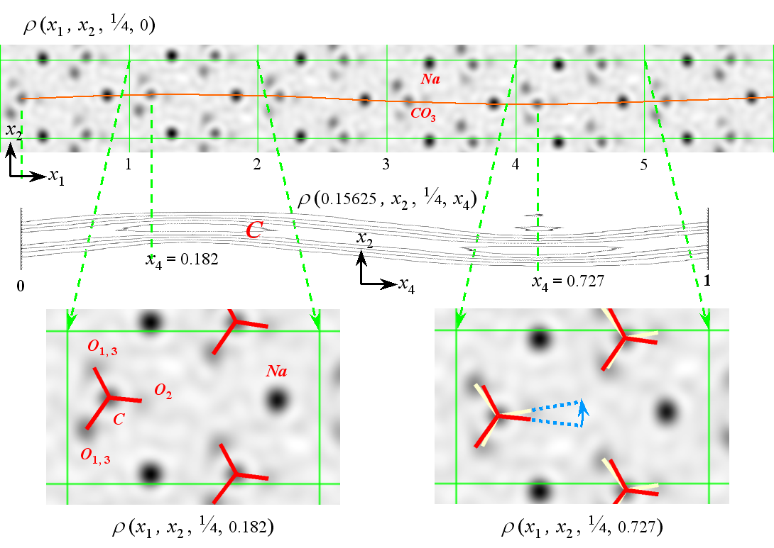

- Visualizing structural modulation of Bi-2212
The incommensurate structure of the high-Tc superconductor Bi₂Sr₂CaCu₂O_{y} (Bi-2212) has been extensively studied in a number of laboratories over the world. However the results are not completely consistent with each other. Here DIMS/VEC produces the visualized structural modulation without relying on any assumptions on the modulation waves. The data used in this test is the same as that of Fu et al. (1995). Crystals of Bi-2212 belong to the superspace group N[Bbmb]1-11 (two-line symbol used in DIMS) with unit cell parameters of the basic structure a = 5.422, b = 5.437, c = 30.537Å and the modulation wave vector q = 0.22b* + c*. SAPI was used to derive phases of the main reflections.

Figure 3
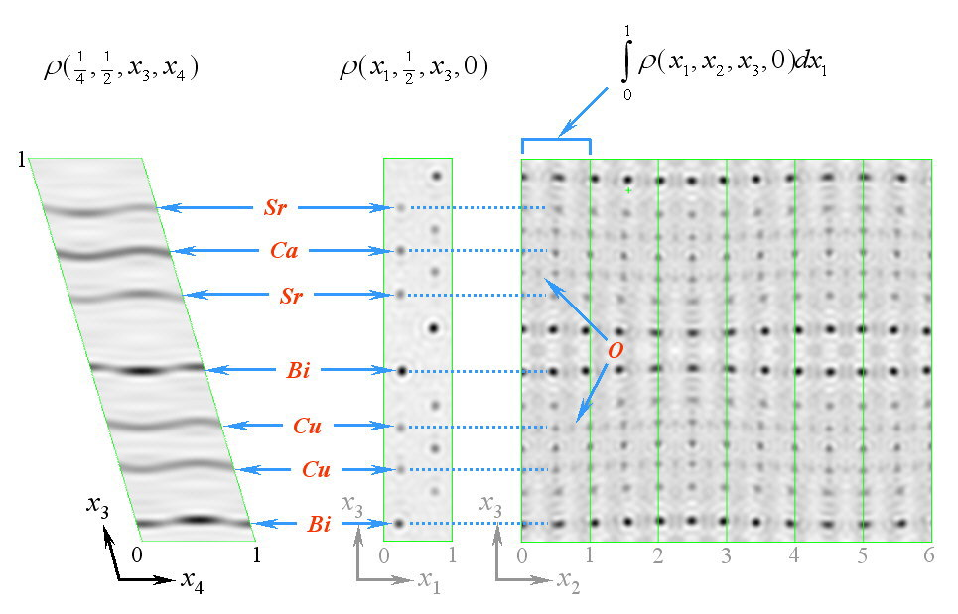

Fourier recycling was used to determine the basic structure. The input file Bi-2212.key was then constructed, with which DIMS/VEC produced the output file Bi-2212.hklm. Electron-density maps were calculated on the VEC platform. The 4-dimensional electron-density function of Bi-2212 projected along the x₁ axis is shown on the right of Fig. 3 giving an overview of the incommensurate structure. Six unit cells are plotted along the x₂ axis. All metal atoms and the oxygen atoms on Cu-O layers are clearly seen. The section at x₂ = ½, x₄ = 0 shown in the middle of Fig. 3 contains all the independent metal atoms. Their modulation is shown on the section ρ (¼, ½, x₃, x₄) (on the left of Fig. 3). Fig. 4 shows atoms on the Cu-O layer and the modulation of the oxygen atom O(1). Fig. 5 shows the saw-tooth modulation of the oxygen atom O(4). It should be emphasized that the saw-tooth modulation here is not a result of least-squares refinement based on a guessed model. In contrast it is revealed objectively before any efforts of model building.

Figure 4
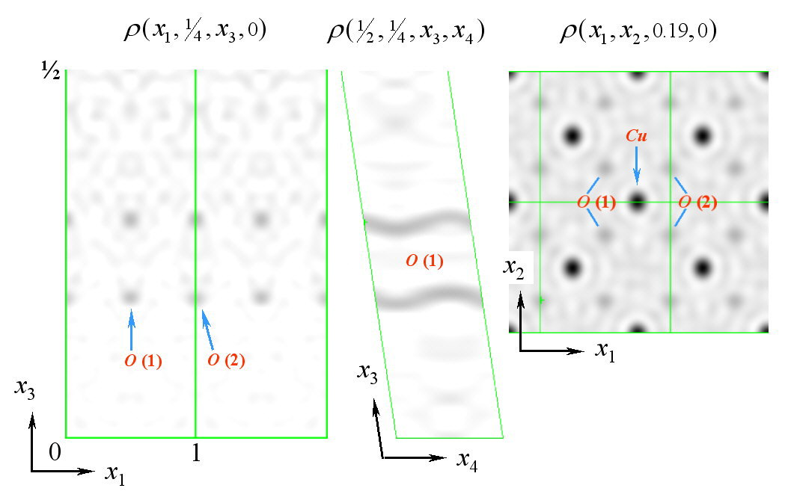

Figure 5
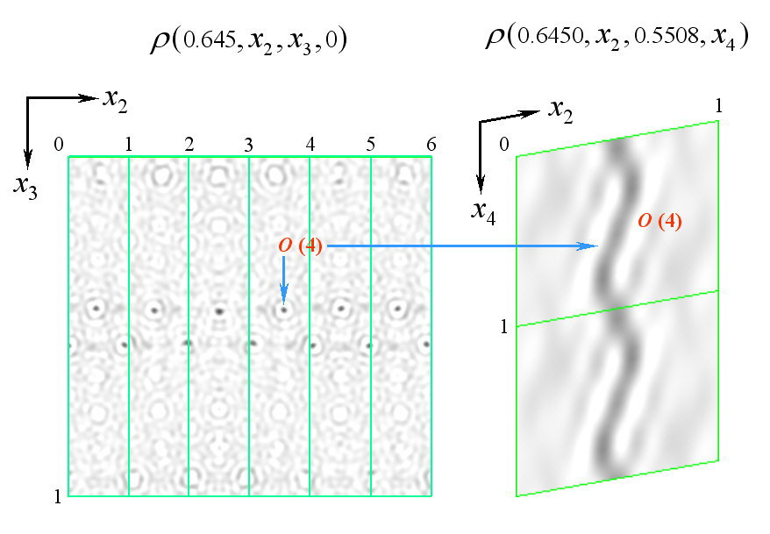

- Solving the 4-dimensional basic structure of the composite crystal (PbS)_{1.18}TiS₂
The composite structure of (PbS)_{1.18}TiS₂ (Van Smaalen et al., 1991) belongs to the space group C2/m (α, 0, 0) s-1. It consists of two subsystems: the subsystem TiS₂ with a₁ = 3.409, b₁ = 5.880, c₁ = 11.760Å α₁ = 95.29º and the subsystem PbS with a₂ = 5.800, b₂ = 5.881 c₂ = 11.759Å, α₂ = 95.27º. Within the experimental error we have b₁ = b₂, c₁ = c₂, and α₁ = α₂. Unlike conventional incommensurate modulated structures, there are no 3-dimensional basic structures corresponding to a composite structure. For (PbS)_{1.18}TiS₂, the basic structure is a 4-dimensional one. It is more complicated to determine such a basic structure than to fine the modulation of (PbS)_{1.18}TiS₂, since there are no known phases available for the direct-method phasing except the origin and enantiomorph fixing ones. The following test shows that DIMS/VEC is capable of solving the 4-dimensional basic structure in a straightforward manner. The input file PbTiS.key contains only main reflections. The symmetry is assumed to be non-centrosymmetric. The output file from DIMS/VEC is PbTiS.hklm, which is opened in a sub-window as shown in Fig. 6. Sections of the 4-dimensional electron-density maps calculated from PbTiS.hklm are shown below. On the left of Fig. 7 we see the “chimney and ladder” structure along the x₁ axis constructed by the TiS₂ subsystem with the period a₁ and the PbS subsystem with the period a₂. On the right of Fig. 7 there are sections through the TiS₂ layer and PbS layer parallel to the (b, c) plane. Note that a₁, a₂, b and c are respectively the projection of the axes x₁, x₄, x₂ and x₃ along the direction perpendicular to the 3-dimensional physical space. Again all the structural features are visible on the direct-method phased electron-density map before any efforts of model building and structure refinement.
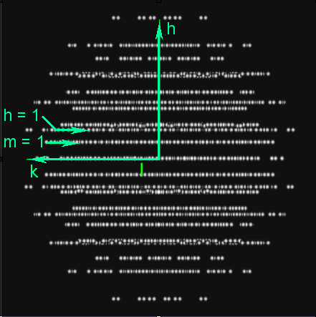
Figure 7
Figure 6
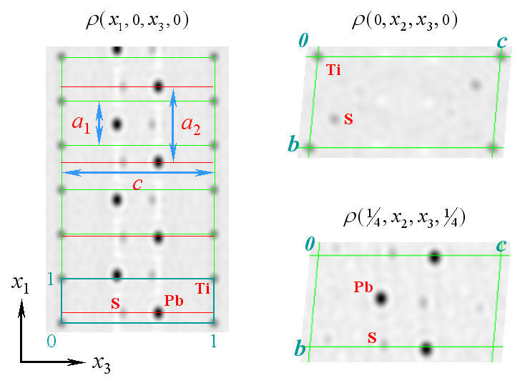
References

Fu, Z.Q. & Fan, H.F. (1994). DIMS --- a direct method program for incommensurate modulated structures. J. Appl. Cryst., 27, 124-127.
Fu, Z.Q., Li, Y., Cheng, T.Z., Zhang, Y.H., Gu, B.L. & Fan, H.F. (1995). Incommensurate modulations in Bi-2212 high-Tc superconductor revealed by single-crystal X-ray analysis using direct methods. Science in China, A38, 210-216.
Fu, Z.Q. & Fan, H.F. (1997). A computer program to derive (3+1)-dimensional symmetry operations from two-line symbols. J. Appl. Cryst., 30, 73-78.
Hao, Q., Liu, Y.W. & Fan, H.F. (1987). Direct methods in superspace I. Preliminary theory and test on the determination of incommensurate modulated structures. Acta Cryst. A43, 820-824.
Li, Y., Wan, Z.H. & Fan, H.F. (1999). MIMS — a program for measuring 4-dimensional Fourier maps of incommensurate modulated structures. J. Appl. Cryst.,32, 1017-1020.
Van Aalst, W., Den Hollander, J., Peterse, W.J.A.M. & De Wolff, P.M. (1976). The modulated structure of γ - Na₂CO₃ in a harmonic approximation. Acta Cryst. B32, 47-58.
Van Smaalen, S., Meetsma, A., Wiegers, G. A. and De Boer, J. L. (1991). Determination of the modulated structure of the inorganic misfit layer compound (PbS)_{1.18}TiS₂. Acta Cryst., B47, 314-325.
Wan, Z.H., Liu, Y.D. Fu, Z.Q., Li, Y., Cheng, T.Z., Li, F.H. & Fan, H.F. (2003). Visual computing in electron crystallography. Z. Krist. 218, 308-315.
Yao, J.X., Zheng, C.D., Qian, J.Z., Han F.S., Gu, Y.X. & Fan, H.F. (1985). SAPI-85: a computer program for automatic solution of crystal structures from X-ray diffraction data. Institute of Physics, Chinese Academy of Sciences, Beijing 100080, P.R. China.

